Introduction

State of Emergency
How to Assemble the De Jure Government of America
A Guidebook for Reconstructing a Republican Form of Government
An Initiative of The American Government’s Resurgence Project
Prepared by: The Union State Assembling Guidebook Committee

How to Assemble the De Jure Government of America
A Guidebook for Reconstructing a Republican Form of Government
An Initiative of The American Government’s Resurgence Project

Acknowledgements

Thanks to graphic artists Tim

Table of Contents

Introduction: State of Emergency

Section 1: The Nature of Sovereignty vs The Nature of Citizenship

Section 2: Republican Form of Government

Section 3: The Law That Governs

Section 4: Reclaiming the American County

Section 5: Forming the Assemblies of Our American Government

Section 6: County Assembly Government Structure

Section 7: Managing Public Government Services

Section 8: Lawful Local Trade and Commerce

Section 9: Definitions

Section 10: Sources

State of Emergency

Brace yourself for what we are about to disclose to you within the 8 Sections of this Guidebook.

Allow us to go straight to the point.

The reason that you are experiencing the government overreach from our United States government is because our American government has not been in operation for over a century.

Our States and Counties have been under military occupation since 1861 by our U.S. Military serving as a mercenary force. Our national identities as native-born Americans have been stripped away from us since 1868. All of our County and State public land resources have been purloined by our U.S. Congress and claimed and collateralized as the property of a Municipal United States corporation since 1871. Our U.S. Treasury has been transferred to the International Monetary Fund since 1924. All of our lawful money, our gold and our silver, has been confiscated by a private commercial banking monopoly since 1933. Every County and State elected government official has been working for the United Nations since 1976. All of this places your town under a State of Emergency.

Indeed, these statements are probably difficult for anyone to accept as true. That is expected. So, we have provided the detailed research presenting these facts at this website: https://claimyourinheritance.info/ and on YouTube in The Resurgence Report video series playlist found here: https://www.youtube.com/playlist?list=PLDm8YreJs4BCqBFeqB13tVSQC4sbiZds7.
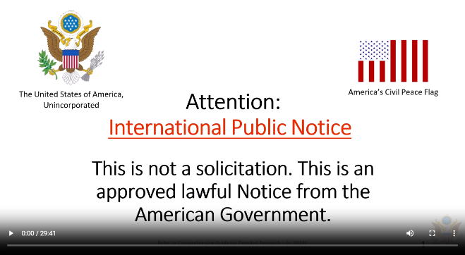
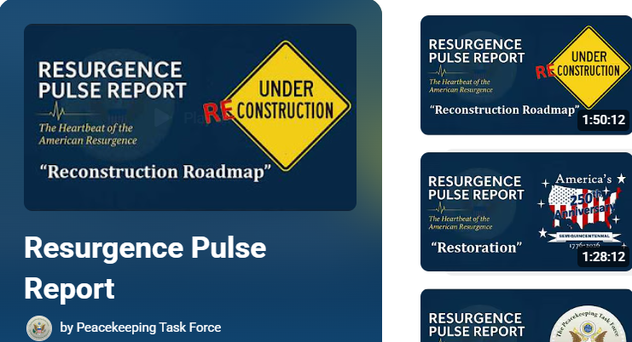

America has been in this State of Emergency for 165 years. At every year that goes by, we are losing more and more of our sovereignty as American people. Many have taken calculated actions to stop this but with limited success. We need every American to accept the responsibility for this and stop it once and for all.

To end the illegal mercenary or military occupation requires that our de jure government provides America and the world with a competent civilian alternative. Although this task will be daunting, it nonetheless, must be undertaken on a systemic level if we are to correct this grave error completely.

In 2017, our restored de jure Federation of States, The United States of America, Unincorporated, chartered an organization called the Peacekeeping Task Force (PKTF) to facilitate a peaceful transition of our communities out of this State of Emergency toward the restoration of a national civilian government occupation.

The PKTF is providing this Guidebook to assist Americans in taking the necessary action to reinstall our lawfully elected public officials and our sovereign Assembly governments at the town, county and state levels.

We need you to recognize that our federal United States government has substituted itself for our American government without your knowledge. In order to prevent undue and unwanted civil unrest, they can only retreat back into their proper jurisdiction when we, the American people, take our proper place as the de jure government in every town in this country.

This information in this Guidebook will show you the how and the what that needs to be done exactly. The foundational principles contained herein and the bulk of this content are based on the extensive research of historian and Fiduciary for the Federation of States, Anna Maria Riezinger and the Federation’s Living Law Firm.

You are not expected to know what a “de jure” government is, let alone, what is meant by a “republican form of government.” You are not expected to know that the federal United States and The United States are both instrumentalities within our American government’s structure and yet not the same entity. So, in order for you to take on this duty as the ultimate Creators of government, you will need to start with studying the Reconstruction Roadmap of the American Government laid out for you on the following pages.

To understand this map, watch the informational video presented by the PKTF titled Resurgence Pulse Report #8 - "Reconstruction Roadmap" (End of Series 1) found at this link:
https://www.youtube.com/watch?v=KQu2gMsSnzI&t=4994s. It introduces the component parts of our traditional American government as our Forefathers originally established it, the progress that has been made thus far to reconstruct it and the untraveled road that lies ahead of us to completely retore it back to full function.

Consider yourselves pioneers. This has not been done before. The reconstruction of our de jure government should have happened following the end of the “so-called” American Civil War, but didn’t.

So, it is left up to us to roll up our sleeves and do it now. It’s now or never.

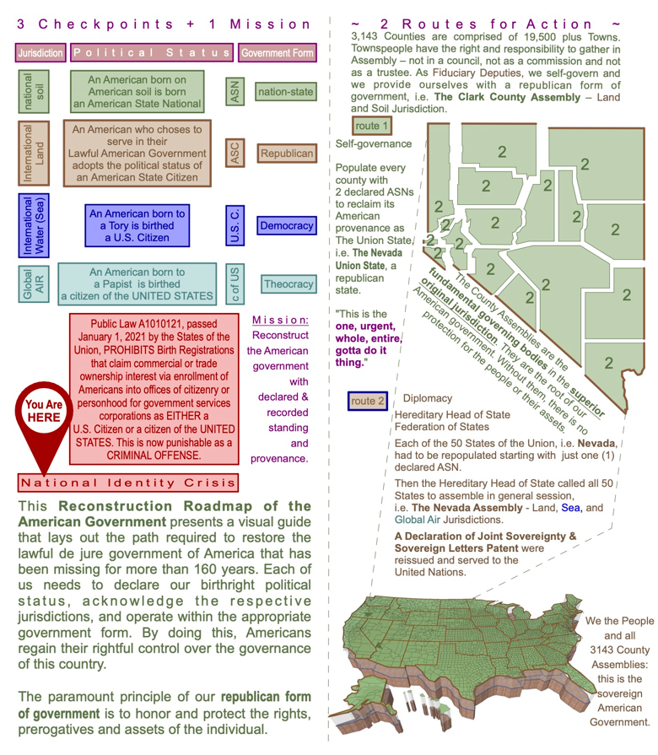
Reconstruction Roadmap of the American Government

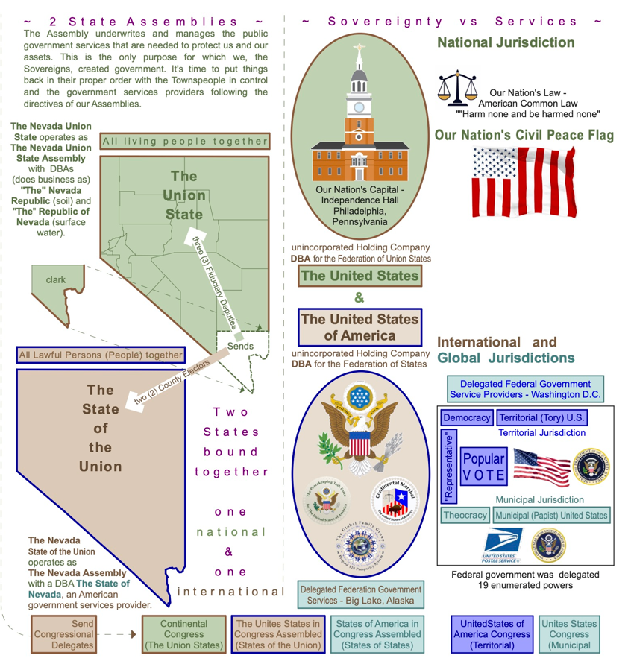
Reconstruction Roadmap of the American Government


Take Away…?

- What year was America placed under military occupation?
- Name the organization responsible for ensuring a peaceful transition to a national civilian government occupation happens?
- Are the United States and The United States the same entity?
- What form of government was America founded upon?
- What has not been going on for 165 years?

