2026

An Initiative of The American Government’s Resurgence Project
Prepared by: The Union State Assembling Guidebook Committee
How to Assemble the De Jure Government of America
A Guide for Reconstructing a Republican Form of Government

Acknowledgements

Thanks to graphic arts, Tim

How to Assemble the De Jure Government of America:
A Guide for Reconstructing a Republican Form of Government
An Initiative of The American Government’s Resurgence Project

Table of Contents

Introduction

Section 1: The Nature of Sovereignty vs The Nature of Citizenship

Section 2:

Section 3:

Introduction

This Guidebook is provided to assist publicly recorded Americans in our task of reinstalling our lawfully elected public officials and our sovereign Assembly governments at the town, county and state levels of our restored de jure American Government.

Recognizing that our United States Government has been substituted for our American Government for 165 years --- yes, since 1861 --- this task will be daunting, but nonetheless, must be undertaken if we are to correct this grave error.

The foundational principles contained herein and the bulk of this content are based on the extensive research of historian and Fiduciary for the Federation of States, Anna Maria Riezinger and the Federation’s Living Law Firm.

You are not expected to know what a “de jure” government is, let alone, what is meant by a “republican form of government.” So, in order for you to take on this duty as the ultimate Creators of government, you will need to first study the Reconstruction Roadmap of the American Government.

As you study the map on the next pages, watch this informational video presented by the Federation’s own Peacekeeping Task Force, Resurgence Pulse Report #8 - "Reconstruction Roadmap" (End of Series 1): https://www.youtube.com/watch?v=KQu2gMsSnzI&t=4994s to get introduced to the component parts of our American government, the progress that has been made thus far and the untraveled road that lies ahead of us.

Consider yourselves pioneers. This has not been done before.

Yes. We have had a fully operational American Government in the past, but we have not had to reconstruct what once was after 165 years of its dormancy. They refer to as “in interregnum.”

The reason that you are experiencing the government overreach from our United States government is because our American government is missing. It’s reconstruction never happened after the American Civil War and nobody told you.

To learn about that backstory, visit https://claimyourinheritance.info/.

Right now, it’s time to roll up our sleeves and attend to the business at hand.

Let’s get started.

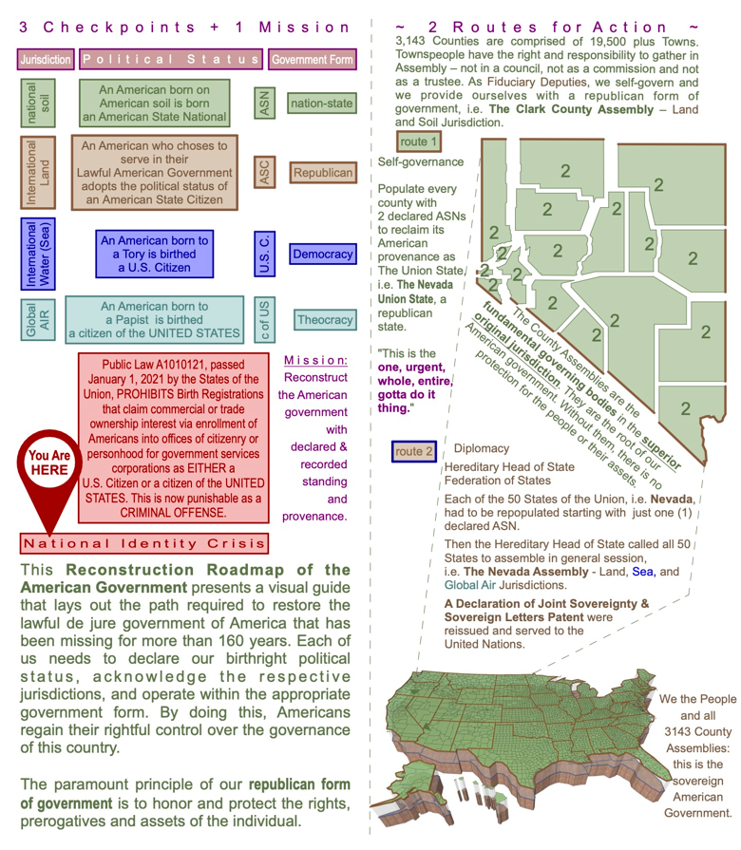
Reconstruction Roadmap of the American Government

Reconstruction Roadmap of the American Government
