Section 1
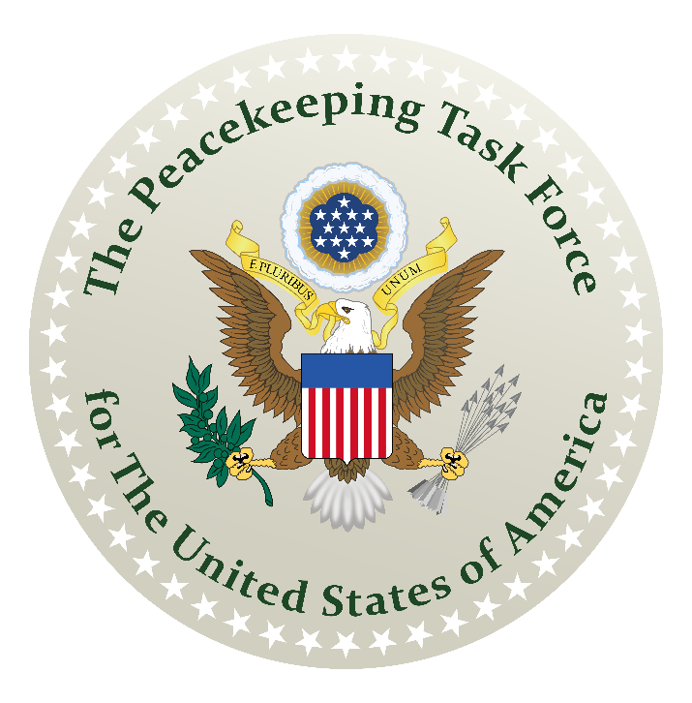
How to Assemble the De Jure Government of America
A Guidebook for Reconstructing a Republican Form of Government
The Nature of Sovereignty
vs The Nature of Citizenship
An Initiative of The American Government’s Resurgence Project
Prepared by: The Union State Assembling Guidebook Committee

How to Assemble the De Jure Government of America
A Guidebook for Reconstructing a Republican Form of Government
An Initiative of The American Government’s Resurgence Project

Acknowledgements

Thanks to graphic artists Tim

Contents
How to Assemble the De Jure Government of America 1
Acknowledgements 1
Key Points 3
Section 1: The Nature of Sovereignty vs The Nature of Citizenship 4
A. Sovereignty of the Townspeople 4
B. A Temporary Government 5
1. According to the Northwest Ordinance of 1787 6
2. According to History Books 6
C. The First Citizens 7
1. Tories, Papists and Americans 7
D. Your Birthright Nationality 8
1. Born in America but Not American 8
2. Unlawful Conversion by Birth Registrations 9
3. Crime Against Public Law A101021 10
4. Demonyms for Nationality 12
E. Identifying Your Political Status 12
1. What Political Status Means 13
2. 3 Categories of Citizens 15
3. 4 Categories of Nationals 15
F. Three Levels to Sovereignty 16
1. Natural Sovereignty 17
2. Group Sovereignty 17
3. Political Sovereignty 17
G. Dependent Sovereignty 17
1. Sovereign Nation-States 18
2. The Claim of Sovereignty by Governments 19
H. Myth of the Sovereign Citizen 20
1. Supreme Court rulings 20
2. The FBI’s Definition 21
3. The Pejorative Label 22
4. Memo: Americans Are No Longer Stateless 23
I. The Crux of the Matter 24
Take Away…? 25

Key Points

In Section 1 – The Nature of Sovereignty vs The Nature of Citizenship

- Every American is a “sovereign in your own right” by inheritance.
- By victory in war, we are a “free, sovereign, independent” people.
- In our sovereign right and power, we created government for our own protection.
- There are six categories of political statuses that we may occupy at any given time.
- Native-born American State Nationals have been unlawfully converted into foreign United States citizens.
- We hire American State Citizens and United States citizens to manage our public government services.
- The American government and its citizenry are Foreign Sovereigns in relationship to the United States government and its citizenry.
- A Sovereign and a Citizen are two distinctly different capacities that cannot coincide.
- The local townspeople are under the governance of County, City and Town municipal corporations created by the State.
- What we have known for the past 165 years are democratic and theocratic forms of government imposed upon us by the United States citizens in the absence of American State Citizens to direct our own republican form of government.

Section 1: The Nature of Sovereignty vs The Nature of Citizenship

Every town in America is in a State of Emergency.

In your town, are real estate deeds filed on property that you buy?
In your town, are people paying property taxes?
In your town, are people using federal reserve notes to pay for goods and services?
In your town, does your County Sheriff ever say, “That’s not my jurisdiction,” related to anything happening in your County?
In your town, is there a Judicial District Court?
In your town, is there a Federal District Court?
In your town, are there banks that provide bank loans to purchase homes and cars?
In your town, do businesses ask you to fill out W-4 Income Tax forms when accepting a job?
In your town, do you pay sales taxes on the products that you purchase?
In your town, are hospitals requiring parents to fill out a birth registration for their newborn babies?
In your town, do people have to register their cars before they can travel on the roads?
In your town, is the “State government” taking children away from their parents?
In your town, are your children’s education and health legislated by a “State government?”
In your town, can your children be taken from you by a “State government?”
In your town, are people jailed for multiple traffic tickets?

All of this is unlawful and illegal activity that townspeople have long accepted as “obeying the law.”

Sovereignty of the Townspeople

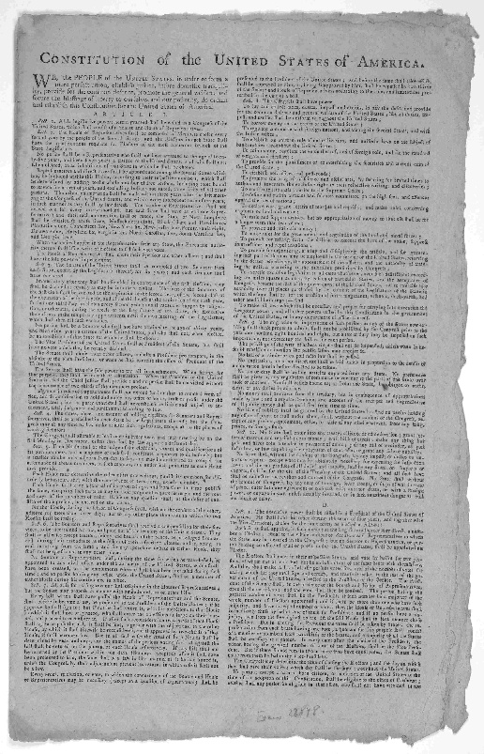
What makes these actions unlawful and illegal is the fact that you have not been fully informed about the nature of these “laws.” They could be deemed lawful and legal if the nature of the “laws” is fully disclosed and you have willingly consented to what is being required of you.

We need to inform you that none of this is “the law.” These kinds of legislations and business activities that townspeople have been subjected to all these years fall under a foreign jurisdiction “of law” called British Admiralty Law and Roman Municipal Law enforced by foreign, private commercial corporations.

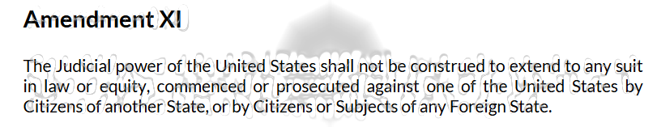
Amendment XI of the Constitution of the United States of America guarantees us freedom from the subjection to such foreign law.
Nonetheless, irrespective of Article XI of our Constitution, your town is being run by foreign, private commercial corporations. These corporations may go by a name something like City of Kankakee or County of Clark or Village of Hopkins Park or Township of Pembroke. All of these private corporations have a DUNS number. They all are incorporated franchises of the federal United States parent corporation under DUNS number 052714196 and its “State” franchisees. Their line of business is in providing your town with public services.

In a 1875 Supreme Court ruling Comm'rs of Laramie County v. Comm'rs of Albany County, 92 U.S. 307, Justice Clifford opines, “Counties, cities, and towns are municipal corporations created by the authority of the legislature, and they derive all their powers from the source of their creation,” which is the State, not the people. When you see the sign that says “corporate limits” alongside the road, you are entering into a corporations’ territorial jurisdiction overlayed onto the physical boundary of a community of people.

These corporations are run by corporate officers. The people whose name appears on the ballot in the so-called “public” elections conducted in your town are the shareholders or “United States citizens” of these private corporations. You also act as a shareholder or “United States citizen” every time you vote for them.

Your voting rights afford you the obligation to be regulated by whatever law, statute, code or ordinance that these private corporations enact. You are voting for the right to be obligated to pay any tax, penalty or fee the corporation deems it wants to impose upon its citizens to generate income. If this sounds counterintuitive, it should.

And yes, corporations have citizens.

If you and your neighbor find yourselves complaining to each other about this thinking that America is supposed to be the land of the free and the home of the brave, then you have to come to terms with the fact that you are not free.

Only sovereign people are free. Citizens cannot be free by definition. They are employees or subjects or may even be slaves under some forms of government. The forms of government that United States citizens work for are both a territorial democracy and a municipal theocratic oligarchy. They are essentially dual citizens and they are obligated to the government for which they serve or work. That is the nature of citizenship.

America began as a fledgling new country of both sovereign people and citizens. They were distinctly different populations. Knowing this about how our original towns used to be constituted will help you discover how to restore the freedoms that you, as townspeople, have lost.

- A Temporary Government

For you to begin to comprehend what has happened to the governance of your town and your sovereignty as townspeople, you will need to learn a short history lesson.

A century and a half have passed since our American government has been in operation. This will come as a shock to the average reader. That is to be expected.

The reason you are shocked is because our public schools no longer teach us the historical fact that the American Government and the United States Government are not one and the same.

1. According to the Northwest Ordinance of 1787

The Northwest Ordinance of 1787, Sections 1, 7, and 12 stipulates three times that the United States government was to be a “temporary government” in respect to the establishing of new States of the Union.

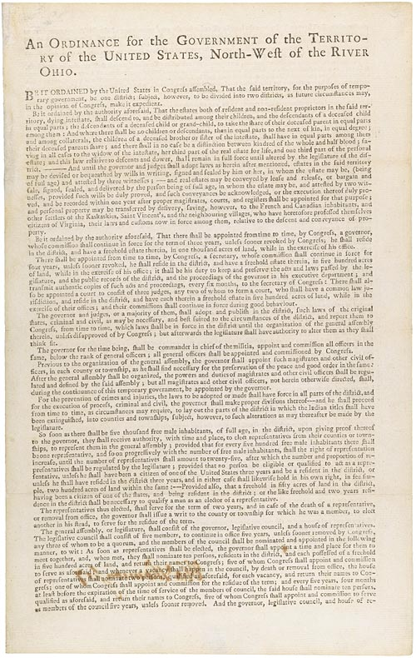
- Section 1: “…That the said territory, for the purposes of temporary government…”
- Section 7: “…shall during the continuance of this temporary government…”
- Section 12: “…with a right of debating but not voting during this temporary government.”

Two times within the Northwest Ordinance in Sections 13 and 14 paragraph 5, it clearly indicates that a “permanent government” needs to be established:

- Section 13: “…that to provide also for the establishment of States, and permanent government therein” and
- Section 14(5): “…shall be at liberty to form a permanent constitution and State government: Provided, the constitution and government so to be formed, shall be republican…”

You will come to learn that the territorial “State” government mentioned in the 1875 Supreme Court case is the temporary de facto State government not the permanent de jure State government prescribed by the Northwest Ordinance.

- According to History Books

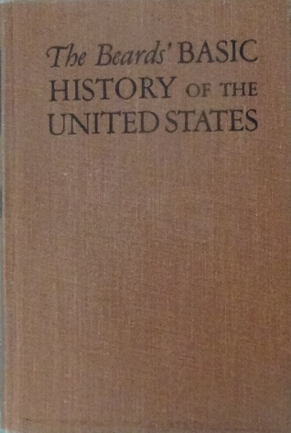
History books that are on the bookshelves at libraries although not on the bookshelves at our public schools do teach us this same historical fact.

In the book, “The Beard’s Basic History of the United States” by Charles and Mary Beard copyrighted in 1944 on page 180, it reads, “Settlers on the Western lands were not to be held permanently under the dominance of the United States Government. They were to be allowed, subject to certain rules, to form governments in their respective territories, draw up constitutions of their own, and at length, as states, join the Union as partners in every respect equal to the thirteen original states. Thus, a promise of self-government preceded the great westward migration.”

These historical references proves that our inherited status is that of a sovereign, self-governing people, separate and apart from the federal United States government’s control. However, somewhere along the way we have lost our sovereignty, and not only that, we have forgotten that we even possessed it. The word itself is even shunned because the federal United States government has caused us to divest ourselves of our own power in order for them to retain their power over us.

Americans stand at the precipice of the 21st century tasked once again with establishing ourselves as “free, sovereign and independent states” as described in the Treaty of Paris of 1783, one in the peace treaty series that ended the War for our independence.

- The First Citizens

Not everyone wanted to be free of the colonial feudalism imposed by the Monarchs of France, Spain, Britain, Netherlands and the Pope. Not all 13 Colonies were British. There were both anti-independence groups and pro-independence groups fighting in the Revolutionary War.

- Tories, Papists and Americans

After the War of Independence was won, the well-being and future of the anti-independence groups, who were the Tories loyal to the King and the Papists loyal to the Pope, were provided for as part of the peace settlement. Everyone would be allowed to keep their "personal" property -- their business interests, intact. Everyone could maintain their political allegiances, too.

Tories could choose to remain loyal Subjects of the King by adopting Territorial Citizenship as a U.S. Citizen.

Papists could choose to remain loyal Subjects of their Pontiff by adopting the status of Municipal "citizens of the United States".

Both these large and well-represented groups would be tolerated by the new American Government as foreign citizens called "inhabitants" and "residents" allowed to be here for the purpose of providing "essential government services" --- services that were firmly established and contractually agreed upon via the constitutions adopted in 1789 and 1790, respectively.

So, from the first, both the Tory Loyalists and the Papists, were protected, kept all their property assets except that their land was held under title as real estate and not really theirs, and a substantial portion of them were hired right off the bat to provide "essential government services" ---- which gave them a catbird seat position to mess with us.

Which they have done for over 200 years.

Most of them probably don't even remember why.

The Tories loyal to the King ensconced themselves in our port cities and got heavily involved in administering "customs houses", taxes, tariffs, trade agreements, and also administering the United States Navy on the High Seas and Navigable Inland Waterways, and all the Maritime and Admiralty Courts. Through their position as our Trustees on the High Seas and Navigable Inland Waterways, they also gained control of the US Marine Corps and overall influence over our military operations, services, and suppliers. Last but not least, they privately became dealers in arms, currencies, tobacco, alcohol and any other contraband "federally regulated" goods.

The Papists loyal to their Pontiff entrenched as what we know today as the Federal Civil Service, and began the build-up of the Agency System we know today as "the Alphabet Soups" --- which are all subcontractors of our Subcontractors, layered up so that the Papists don't have any work to do and no accountability, either.

So, you see, the first citizens of our new country were not just Americans. Tories, Papists and Americans were all employed in offices required to provide us with public government services. This aspect of the historical accounts provides an insightful perspective that’s missing from our schools’ classrooms which will cause you to look at your local government significantly differently.

Your Birthright Nationality

Americans are born as American State Nationals, which means we are naturally considered sovereign men and women —a right established after the War of Independence in 1783. We can temporarily give up this status to serve as State Citizens, which refers to people holding elected positions in State or County Assemblies for the American government. If we choose to work for the incorporated County, State, or Federal governments’ departments and agencies—either as a U.S. Citizen under the British Territorial system or as a Municipal citizen under the Roman Municipal system—we also give up our original status while serving in those roles. However, in all these cases, people keep the right to return to their original status as American State Nationals once their service or employment ends or is revoked.

Born in America but Not American

Most of the people who are born in America think of themselves as Americans and consider themselves as loyal to this country as anyone else, but that ignores the entire history of these "federal" government organizations and their administration, which is still British and still Papist, respectively.

This dual citizenship nature has continued throughout the years resulting in 320 million people who have been registered as foreigners in their own country, without their knowledge or consent.

You believe that you are Americans and that you have the rights of Americans, but you do not.

You have been cheated out of that via legalized fraud and unlawful conversion; it was done via registration of American babies as U.S. Citizens, and subsequently as citizens of the United States, and it's been ongoing since the 1920's.

Unlawful Conversion by Birth Registrations

Your nationality was unlawfully converted from an American State National to a United States citizen way back when you were just a baby by the U.S. military through one of its uniformed officers who was your gynecologist or nurse by his or her act of signing your birth certificate to certify that your parents knowingly acting as the “informant” did relinquish your national status for a foreign United States citizen/subject status. Why do we find the word “informant” on a birth registration?

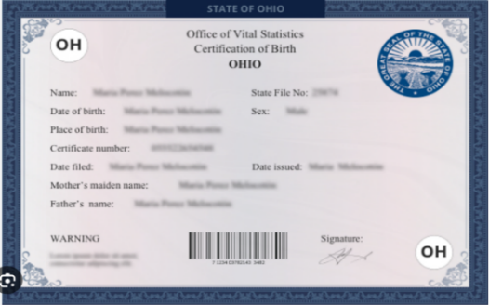
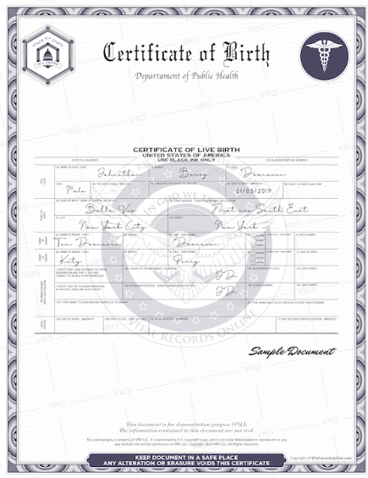
37 U.S. Code § 101 – Definitions: (3) The term “uniformed services” means the Army, Navy, Air Force, Marine Corps, Space Force, Coast Guard, National Oceanic and Atmospheric Administration, and Public Health Service. (23) The term “member” means a person appointed or enlisted in, or conscripted into, a uniformed service.
According to Black's Law Dictionary, an informant is someone who confidentially supplies the police or government with information about a crime.
According to 50 USC § 3126(6) - Definitions
(6) The term “informant” means any individual who furnishes information to an intelligence agency in the course of a confidential relationship protecting the identity of such individual from public disclosure.
The short-form birth certificate is the Municipal citizen of the United States registration.

Informant Signature
The long-form birth certificate is the Territorial U.S. Citizen registration.

All of you who were born in America and raised as Americans believe that you are free, but you are not. Why? 1. You have accepted enfranchisement and registered yourselves as voters. 2. You have not objected to being registered as U.S. Citizens, and later, being registered as Municipal citizens of the United States, too. Therefore, you are foreigners on your own land and not one of the free, sovereign and independent people.

3. Crime Against Public Law A101021

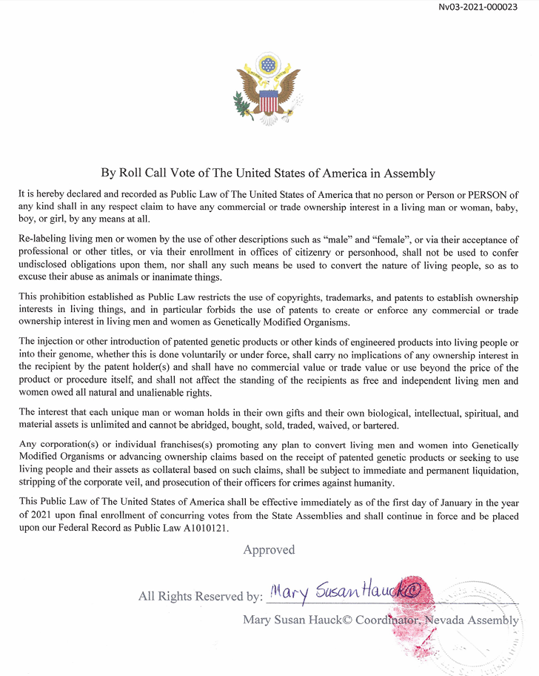
Public Law A101021 was passed on January 1, 2021 by the States of the Union that PROHIBITS birth registrations to claim a commercial or trade ownership interest via enrollment of Americans into offices of citizenry or personhood for government services corporations as EITHER a U.S. Citizen or a citizen of the UNITED STATES. This is now punishable as a CRIMINAL OFFENSE.
This is now “the law” in America. It is now a punishable crime for anyone to presume upon you the status of a foreign citizen when you had no intentions or knowledge of registering as one. In the same token, if you are claiming to be a U.S. Citizen or a Municipal citizen of the United States, you will need to produce the employment credentials provided to you by your Territorial or Municipal government services corporation’s employer.

Demonyms for Nationality

When asked if you are a U.S. Citizen, what do you say? If you are not, you would say, “No,” followed by what your State nationality is.

In the book, Government Printing Office Manual, Section 5.22-5.23 under the heading, “Nationalities, Etc”, you will find the federal government’s classification demonyms for the nationalities of Americans. It reads on page 109:

Nationalities, etc.

5.22. The table on Demonyms in Chapter 17 “Useful Tables” shows forms to be used for nouns and adjectives denoting nationality.

5.23. In designating the natives of the States, the following forms will be used.
The 50 Nationalities of the Sovereign Nation-States of America
Alabamian | Hawaiian | Massachusettsan | New Mexican | South Dakotan
Alaskan | Hoosier (Indiana) | Michiganian | New Yorker | Tennessean
Arizonan | Idahoan | Minnesotan | North Carolinian | Texan
Arkansan | Illinoisan | Mississippian | North Dakotan | Utahn
Californian | Iowan | Missourian | Ohioan | Vermonter
Coloradan | Kansan | Montanan | Oklahoman | Virginian
Connecticuter | Kentuckian | Nebraskan | Oregonian | Washingtonian
Delawarean | Louisianian | Nevadan | Pennsylvanian | West Virginian
Floridian | Mainer | New Hampshirite | Rhode Islander | Wisconsinite
Georgian | Marylander | New Jerseyan | South Carolinian | Wyomingite

Nationality is inherited as a birthright. It happens automatically the day you are born. In America, we inherit our nationality from our State. We are New Yorkers, Wisconsinites, Californians, and so on. Thus, our natural birthright political status is an American State National.

- Identifying Your Political Status

Many people living here in America don’t even know that our actual American Government was missing in action for over a century --- 137 to be exact, from 1861 - 1998. Neither do they know that the Americans were missing too. Most of you don’t know that United States citizens run the United States Government and it takes American State Citizens to run the American Government. Put this way you can clearly see the distinction and the logical association.

We have United States Nationals and United States citizens. We have American State Nationals and American State Citizens. These are just four valid and distinct political statuses you can hold here in America.

You must come to comprehend this term known as “political status,” and the value it holds. Your political status dictates your rights, your privileges and your civic duty. Your town is populated by people who don’t know what their rights are, what privileges they have or what their civic duty is. Not knowing what your political status really is created this environment where your town has been usurped by those who do know what their political status is to prey upon the others who don’t even know what the word “political status” means.

The intention is to maintain the system of colonial corporate feudalism that the British and the Papacy had going on all of the world at the time. It was the way they did business all over the world not just in early America, and still do. The colonies were not actually a "colony" in the sense that people normally assume. Colonies were joint investment ventures who had been apportioned a charter to inhabit and develop resources in America. The American Revolution was indeed men breaking free from the colonial corporate feudalism obligations.

These colonies were companies that became incorporated corporation starting in the 1720’s manned by citizen subjects who got contracts to provide government services in concessions agreed to during the negotiations of peace treaties that ended the Revolutionary War.

When you look around your own town, is it run by municipal corporations or by free, sovereign and independent people? Are you being forced to comply with legislation, statutes and ordinances that takes your property and rights from you and you are being told its “the law?”

If you don’t know what your actual political status is, then you don’t know what legislation, statute, ordinance or “law” even applies to you. Neither, will you ever realize that “promise of self-government” we are owed.

- What Political Status Means

What does “political status” mean?

Political status is determined by virtue of your consent to be governed by a specific body politic—a group of people with laws and customs.

There are only two types of governing body politics here in America, the sovereign, unincorporated American government --- the permanent, republican government, and the foreign, incorporated subcontractors of the British Monarchy d.b.a. the United States of America (USA), Inc. (Tories) and the Roman Papacy d.b.a. the UNITED STATES (US), INC., (Papists) who provide America with essential governmental services.

The American government operates under The Unanimous Declaration of Independence of 1776, not under a constitution. The foreign United States government operates under constitutions. They are The Constitution of the United States of America (British Territorial Contract) and The Constitution of the United States (Papist Municipal Contract). These are service contracts made with the American Federation of States of the Union d.b.a. The United States of America, Unincorporated, in 1789 and 1790, respectively. They delegate limited powers to these subcontractors authorizing them to perform the essential governmental services enumerated in their respective contracts.

Your political status can be as a national or as a citizen if you consent.

American State Nationals can become citizens either by contract as employed by a foreign citizen of the government services providers or by serving in a public office for our American Government. Both are voluntary.

The definitions for citizen vary depending on who you chose to work for. It can mean employee, officer, subject, slave and indentured servant. The contract you sign should disclose to you which of these capacities you will be serving. If this is not fully disclosed to you, then there can be no lawful consent.

There are six categories of political statuses that those living in America can fall under. Three by employment as a citizen and four by birthright as nationals. We, Americans, have not been taught that such a delineation in our population exists. So, our ignorance has made us incompetent to self-govern as Americans and manage our own permanent, republican form of government as was prescribed by the Northwest Ordinance.

3 Categories of Citizens
 | 3 Categories of Citizens in America
American State Citizens | An American State National who divested himself of his sovereignty to serve as an elected officer in the American government. British Territorial United States Government established under the 1789 Constitution of the United States of America (Territorial) very clearly recognizes the States and State Citizens: Article 4, defines “State Citizen”.
British Territorial U.S. Citizens | The Definitive Treaty of Peace 1783 that ended the Revolutionary War described the "citizens" as "Inhabitants." A British subject is an inhabitant "residing" here, for the purpose of providing essential government services (Article IV). Categories of U.S. Citizens include (a) those born in the District of Columbia, Guam, Puerto Rico or what we consider the "Territories and Possessions"; (b) federal civilian employees; (c)federal military personnel on active duty; (d) federal welfare recipients; (e) elected officers of the federal and federalized "state of state" corporations; (f) political asylum seekers; (g) African Americans who were never accorded their State National status.
Municipal citizens of the United States | A federal franchise corporation, and also, an employee of the Municipal United States corporation.

- 4 Categories of Nationals
 | 4 Categories of Nationals in America
American State Nationals | The Definitive Treaty of Peace 1783 that ended the Revolutionary War described American State Nationals as the free, sovereign, and independent people of the continental United States; also spelled, American state national. The native-born people of one of the several States of the Union are free and independent sovereigns and are foreign to the federal United States government, hence Foreign Sovereigns.
United States Nationals | All U.S. Citizens are United States Nationals, but not all United States Nationals are U.S. Citizens. United States Nationals also include those born in American Samoa and Swains Island.
American Nationals | Refers to people born in American Samoa and Swains Island.
Foreign Nationals | Citizens from other countries residing here in America.

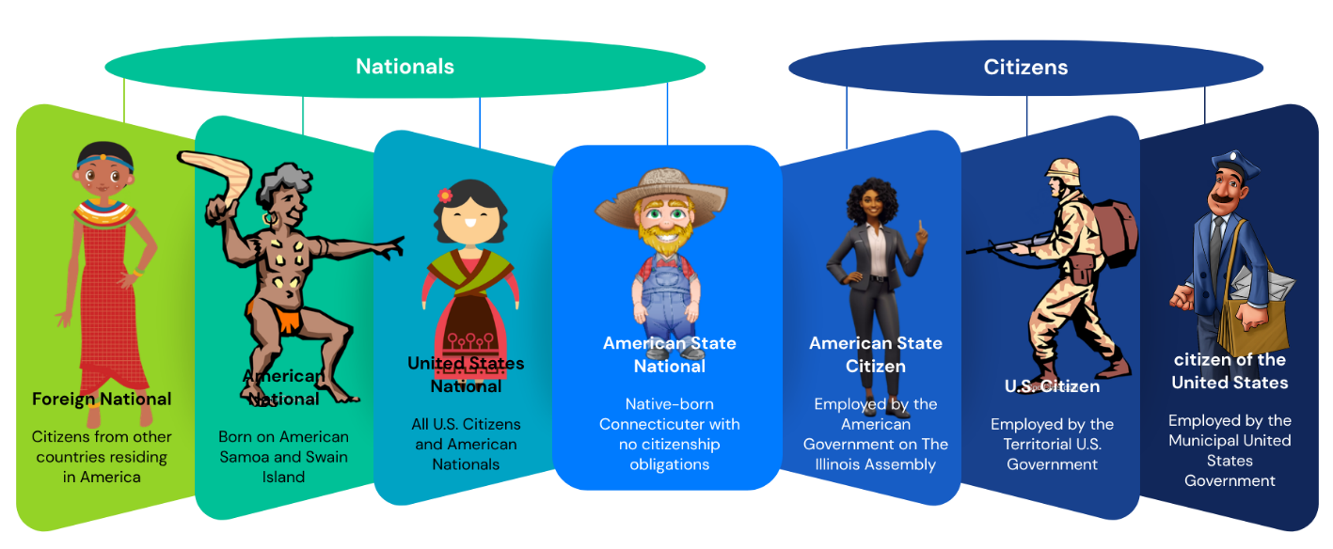
We will cover which “laws” governs these categories of political statuses in Section 3: The Law That Governs.

Three Levels to Sovereignty

In this country, the Founders of our government adopted and espoused Lawful Sovereignty and the concept that Mankind was born free and should remain free to believe and live as we see fit, and so long as we cause no harm, the Government should not interfere with us.

They also found a way for us to enjoy Legal Sovereignty. You have all inherited "sovereignty in your own right" and the right to own property --- as opposed to being considered property -- by being born here.

Because this kind of sovereignty is inherited from other sovereigns, you cannot avoid being a sovereign in your own right from the moment of your birth, but you can (if it is done consciously and voluntarily -- which in our case, it never is) "pledge" allegiance to other sovereigns or symbols, and become subjected to them as a result.

An example of how you are unconsciously yet voluntarily do this is the times when you place your hand on your heart and pledge allegiance to the flag of the United States of America, while not knowing this flag is our Title IV flag on loan to our British Territorial subcontractor dba “the” United States of America and its citizens to fulfill their contract to defend our enemies both foreign and domestic on the navigable and inland waterways. Are you employed by the British Territorial U.S. Military? Then, you are not a British Territorial U.S. Citizen but you have been made to pledge that you are.

Just as your rights are not created by nor granted to you by any Constitution, but are instead guaranteed by the Federal Constitutions -- a different concept entirely --- your Sovereignty is not granted, it's shared.

There are three variations and levels to sovereignty. In order to experience any one level of sovereignty in America, requires one to embrace the nature of the other two.

Natural Sovereignty

Level 1. Individual sovereignty – is endowed by our Creator. This is the foundational level upon which all other variations of sovereignty arise.

Our individual natural sovereignty results from our gifts of unique character and conscience, and the common gifts of mobility, memory, reasoning, learning, and logic.

This is what we call "Lawful Sovereignty" which is what our Forefathers touched upon with the concept of "Natural and Unalienable Rights". These are the "gifts of Nature and of Nature's God", as Thomas Jefferson put it: the exercise of freewill, to be able to think, talk, move about, work, live, and all those other fundamentals we tend to take for granted.

We are living men and women graced with the freewill and blessings of our Creator. We have the natural sovereignty that is the natural inheritance of all Mankind.

Even in the world of men and their paper kingdoms and empires, we are sovereign.

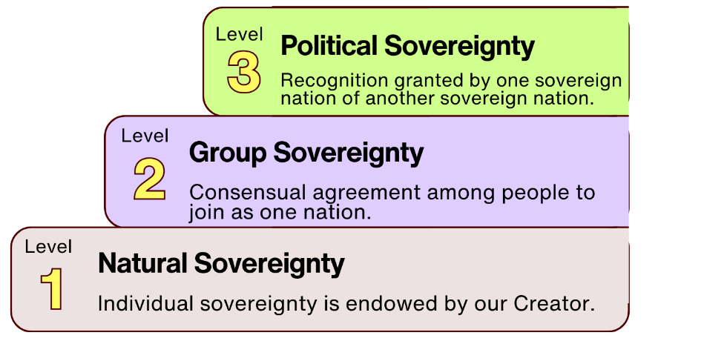

Group Sovereignty

Level 2. Group sovereignty - consensual agreement among people to join as one nation.

Our group sovereignty results from people of like-mind coming together in agreement to form a nation of people asserting their sovereignty and their right to their practices, culture, language, beliefs, and laws.

Nations are formed as a result of group sovereignty, ie. Nation of Islam, Moorish Nation, Lakota Nation, etc.

Political Sovereignty

Level 3. Political sovereignty - recognition granted by one sovereign nation of another sovereign nation.

Our political sovereignty depends on the recognition of all the other sovereign nations respecting our right to self-govern.

This is formally called "Legal Sovereignty" which is what goes on with Monarchies and governments. This worldly version of Sovereignty related to this country was won by the Force of Arms when we won The War of Independence, and it was settled upon this nation by William Belcher, a colonel in the Continental Army from Connecticut and heir of French King, William the Conqueror, who shared his sovereignty with every man and woman born on American soil conferring to us the status of “sovereigns in our own right.”
The Belle Cher Clan were Sovereigns and the Donors of their Coat of Arms attached to The Great Seals
of The United States and The United States of America and any dependent seals of service providers.

Unincorporated Sovereign American Government | Incorporated  British Territorial Government Services Provider | Incorporated  Roman Municipal Government Services Provider | Unincorporated American Government Services Provider

Did You Know?

The late James Clinton Belcher was the Hereditary Head of State of The United States of America who reissued a Joint Declaration of Sovereignty and Sovereign Letters Patent to restore our American Government, our provenance and standing.

“The Belle Chers are modern progeny of the Cherusci, a clan-nation of the Rus, that defeated the Roman Emperor known as Augustus in their year known as 9 A.D. in the Battle of Teutoburg Forest.

We conquered England as “the Normans” in the Norman Conquest a thousand years later. They obscured our identity, by referencing the place we came from instead of our family name, but they know who we are.

As a result of the Norman Conquest our people became sovereigns in their own right in England, so that when the head of our Clan, William Belcher (anglicized version of Belle Cher) fought as a colonel in the American Continental Army and was victorious, he was enabled to bequeath his sovereignty in England to all other American soldiers and sailors in the same manner as William the Conqueror conferred sovereignty to his loyal Barons.

This sovereignty was won, fair and square, by force of arms and physical possession. William Belcher not only conferred sovereignty on the veterans of The War of Independence, but also on all those born on the land and soil of this country forever afterward.

The Great Seal of the United States and the Great Seal of the United States of America were granted and made part of the Belcher family heraldry as a functional coat of arms protecting American shipping and commerce from adverse claims by any other sovereign, clan, or government --- including the British Monarch operating “Great Britain” as a commercial trading company and the UNITED KINGDOM as a municipal corporation.

There can be no doubt that we are a sovereign people, by nature, by freewill, by conquest and by firmly recorded claims of right and divine protection.

Our purpose has never been to harm or coerce or enslave anyone; we conquered the Roman Legions, we conquered the armies of the Anglo-Saxons, we conquered the armies of the Irish Celts, and we conquered the armies of the British again in The War of Independence for one simple reason – our natural right to be left alone and set free from the citizenship obligations and serfdom they impose on living people, the False Claims they make against our assets, and the other lies they tell on paper.

We retain our natural and unalienable rights despite the snares of the Liars and despite their wish to avoid their contractual obligations to provide us with good faith service and protection of our persons as stipulated under Article IV of their specific constitutional service contracts.” – Anna Maria Reizinger, Fiduciary of The United States of America and widow of James Clinton Belcher, March 11, 2026

Dependent Sovereignty

Let’s talk more about what this dependent nature of sovereignty is: Why a sovereign man or woman will not experience his or her sovereignty without both group sovereignty and political sovereignty exercised.

In order for townspeople to return your communities back to the republican form of government as free, sovereign and independent people, you must learn the nature of sovereignty from every angle. In the world of politics today, the word itself is only attributed to governments, not to the people themselves. You will learn that this is not in alignment with the American principles of government.

In our principles of governance, the nation-state, for example, Wisconsin, also known as “republican state” and “Union State,” that is composed of the individual counties, and its State of the Union, Wisconsin, that is composed of the entire geographical landmass as one unit, protects all the people who live in Wisconsin and guarantees to them the blessings of self-determination, an equal share of public resources, abundant freedom, and guaranteed natural rights. People of all creeds, backgrounds, colors, religions and cultures benefit from the sovereignty of their nation-state.

Sovereign Nation-States

The nation-state thus embodies a larger, more inclusive, and generalized political sovereignty, upon which the native group sovereignty depends.

This is why when our American government re-published its Sovereign Letters Patent in 2015, the sovereignty of the nation-states was declared first and the sovereignty of the dependent sovereign nations was declared second.

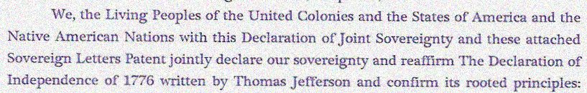
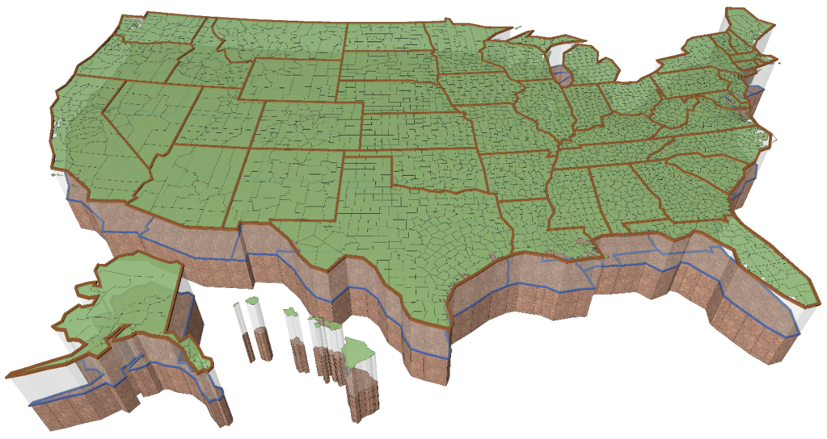
One does not exist without the other.
United Colonies = National nation-states
States of America = International Nation States

We will note that our American Government has always maintained the special status of Native Americans and their numerous nationalities and has readily agreed that they are and should forever be free of taxation of any kind. This is a recognition in its own right that they are Dual Nationals with a pre-existing right to be here and to be free from the financial burdens and conventions of our government.

So, the native nations are sovereign because their members are also members of nation-states that are sovereign. All native groups have a joint interest in preserving the nation-states as a result.

There is also the fact that Natives have guaranteed individual ownership interests in the nation-states like all other Americans, and they would lose that if they try to take over the land and soil jurisdictions held by the nation-states.

You must have sovereignty to begin with, and then, you have to retain legal and lawful standing in order to enforce sovereignty.

We exist as a sovereign people; therefore, we also have sovereign nation-states.

The sovereignty of the people devolves upon them from "Nature and Nature's God". We are born with free will and freedom of movement. We can think what we like and say what we dare to. We are not bound by any Social Contracts. We are not part of any greater construct, apart from the Earth itself.

In the world of men, we established our sovereign nation-states, known as the Union States, as a consequence of our own natural sovereignty.

In international jurisdiction, we exercise sovereignty via grant of sovereignty from those already sovereign by birth; we sail under the auspices of a clan and nation which has never been conquered, the Belle Cher Clan.

In global jurisdiction, our business affairs are secured by our standing on the land and at sea, so that in all things, by free will and by choice and by rule enforced by force of arms, by custom, and by tradition, the American people are free, independent, and sovereign people.

And so are our several nation-states: Pennsylvania, New York, New Hampshire, Vermont, et alia. (Note – in the old Latin-based system of nomenclature, these states were styled as pennsylvania, new york, new hampshire, vermont, etc.)

All the sovereignty of this country is vested in its people and in its several, now fifty, nation-states.

The Claim of Sovereignty by Governments

Our sovereignty is not vested in any collective instrumentality of government, such as The United States or The United States of America. Such unincorporated instrumentalities are limited to representing the sovereignty of the nation-states they serve. They are not sovereign in-and-of themselves. Thus, the character of sovereignty is indigenous by nature, attached closely to the living men and women who self-govern their own lives, and who then direct the course of their common government.

Their Sovereignty is represented in international realms by their unincorporated Federation of States known as States of the Union (This Federation is viewed as a Confederation from the standpoint of the Union States, but as a Federation by the rest of the world).

The States of the Union belong to the Union States.

The realms of land and soil exist in perpetual union as a fact of nature, so that the sovereign Union States abide in eternal joinder with their States of the Union, with the Union States directly presenting the government of the nation-states -- our national jurisdiction, and the States of the Union representing the Union States in international jurisdiction.

Additionally, at no point does the sovereignty of the people nor the sovereignty of their nation-states devolve to any incorporated entity whatsoever, referring to our government services providers who under contract by a constitution and are not actual governments at all.

Myth of the Sovereign Citizen

“Our federal government has instructed our federal, state, and local police agencies that everyone who purports to be a sovereign should be treated as a terrorist. They've also brainwashed the American public into believing that being a sovereign is anti-American and unpatriotic.

What is sovereignty?

It is the inherent right and prerogative of a civilized people to rule itself and to dictate all the forms and conditions of the institutions it sets up to carry out this rule.” - Judge Dale Retired, Thursday, April 11, 2013.

Now we have already mentioned that the United States government had temporary authority over Territories prior to them becoming enrolled as a State of the Union, with equal footing to all free, sovereign and independent State. At such time, it erected its permanent, republican State government. Thus, there exists a United States government and an American Government.

We have already mentioned that Americans enjoy three variations of sovereignty being sovereign people where one cannot be exercised without the other --- natural, group and political sovereignty.

We have already mentioned that Territorial (Tory) or Municipal (Papist) citizens were separate populations living and working alongside the Americans as agreed to by Treaties ending the Revolutionary War.

We have already mentioned the 5 other legitimate political statuses that exist in addition to the U.S. Citizen here in American --- American State Citizen, Municipal citizen of the United States, United States Nationals, American State Nationals, American Nationals and Foreign Nationals.

Supreme Court rulings

Let us add to that a mention of a few Supreme Court rulings confirming what I have already presented:

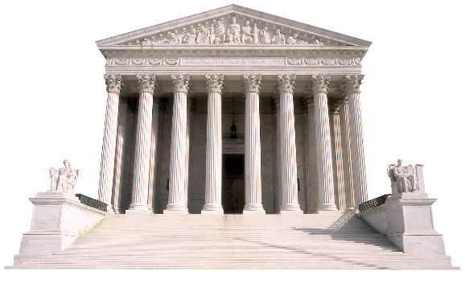
“There is in our Political System, a government of each of the several states and a government of the United States. Each is distinct from the other and has citizens of its own.” – US vs. Cruikshank, 92 US 542

“There are two classes of citizens, citizens of the United States and of the State. And one may be a citizen of the former without being a citizen of the latter.” – Gardina v. Board of Registers 48 So. 788, 169 Ala. 155 (1909)

According to Bond vs UNITED STATES, 529 US 334 (2000), “the Supreme Court held that the American People are, in fact, Sovereign and not the States or the Government. The court went on to define that local, state and federal law enforcement officers were committing unlawful actions against the sovereign people by the enforcement of the laws and are personally liable for their actions.” – by Judge Dale Retired, Thursday, April 11, 2013

Now given these references mentioned, let’s bring a proper perspective to what a “sovereign citizen” actual is.

The FBI’s Definition

The two things, "sovereign" and "citizen", are mutually exclusive political statuses. When you combine the two, you get nonsense. This is known as an "oxymoron" – when you combine two mutually exclusive terms or ideas.

Although “sovereign citizen” is an oxymoron, it was coined by the Federal Bureau of Investigation and is defined in their FEDERAL BUREAU OF INVESTIGATION’s Domestic Terrorism Reference Guide - September 2023, as “a U.S. Citizen who claims to have special knowledge or heritage that renders them immune from government authority and laws.”
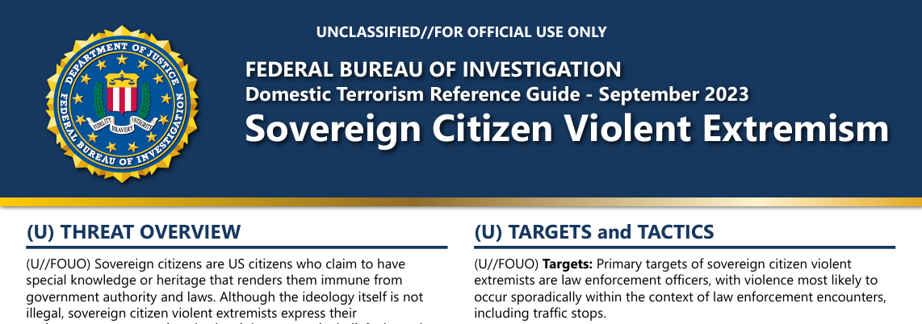

The FBI provides this caveat to their definition in the footer on page 1:

“(U) Disclaimer: Domestic Violent Extremists (DVEs) employ several indicators, some of which may be criminal and others which may constitute the exercise of rights guaranteed by the US Constitution. Under FBI policy and federal law, no investigative activity may be based solely on First Amendment activity. The FBI does not investigate, collect, or maintain information on US persons solely for the purpose of monitoring activities protected by the First Amendment. All personnel should exercise sound judgment and discretion in evaluating the totality of circumstances surrounding any of these indicators in order to determine whether a law enforcement or intelligence response or activity is warranted.”

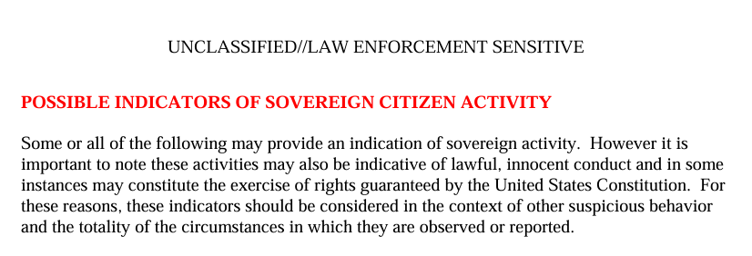
On page 2 of the FBI’s training document called Sovereign Citizens: An Introduction for Law Enforcement (2010) under section titled: POSSIBLE INDICATORS OF SOVEREIGN CITIZEN ACTIVITY, the caveat reads: “Some or all of the following may provide an indication of sovereign activity. However, it is important to note these activities may also be indicative of lawful, innocent conduct and in some instances may constitute the exercise of rights guaranteed by the United States Constitution. For these reasons, these indicators should be considered in the context of other suspicious behavior and the totality of the circumstances in which they are observed or reported.”

The Pejorative Label

The term "sovereign citizen" has been widely used as a pejorative label by media outlets, government entities, and critics who wish to discredit those seeking lawful recognition as sovereign individuals. This label often conflates legitimate efforts for sovereignty with fringe ideologies or pseudo-legal tactics. However, it is essential to distinguish between peaceful movements advocating for lawful status correction—such as those led by American State Assemblies—and isolated incidents involving misuse or misinterpretation of sovereign principles.

The inevitable dismantling of this pejorative lies in education and awareness. As more people understand that sovereignty is rooted in lawful traditions rather than contrived theories or pseudo legal practices, they will reject misleading narratives designed to undermine legitimate efforts toward reclaiming personal autonomy. Sovereignty is not about rejecting law but about restoring alignment with natural law principles free from corporate entanglements.

Memo: Americans Are No Longer Stateless

The federal United States government can no longer claim that Americans are stateless. These incidences may indeed be American exercising rights guaranteed by the Constitution. It would only require a simple check of their credentials to verify if they are a National or a Citizen to determine what jurisdiction of “law” applies to them.

Instead of following jurisdictional protocols, most officers more than likely will insist that you can be nothing other than a U.S. Citizen or you are “stateless.” To be regarded as “stateless” equates to them labeling you a “sovereign citizen.” They do this because of the mistraining they are being given using those documents we just discussed.

No Federal Department, Agency, or Official has any authority to misrepresent, mischaracterize, or misaddress these Americans. No court lacking a fully disclosed contract has any authority to summon or address these people in any way whatsoever. They are foreign.

They have always been foreign with respect to these Federal Subcontractors, and they still are.

It follows that the Federal Bureau of Investigation has no right, reason, or cause to mislabel their foreign sovereigns as "Sovereign Citizens".

We are "sovereign" alright, and we have the case law and contracts and treaties to prove that; but we owe no citizenship obligations to any Federal entity.

Some of us are, indeed, State Citizens, and serve the government of our State of the Union --- but our form of Citizenship is voluntary and non-contractual and foreign, in no way resembling the indentured servitude and slavery engaged in by the citizenry of our foreign incorporated Federal Subcontractors.

Our State Citizens created and adopted all three (3) Federal Constitutions, and are the American Principals having the provenance, standing, and authority to enforce these venerable Service Contracts on our erstwhile Federal Subcontractors.

Perhaps it is this fact that causes these same Federal Subcontractors to attempt to discredit our State Citizens and their authority, and to also to react in fear.

The Head of State for our sovereign American government, James Clinton Belcher, has restored the American government as of 1998. The 50 States of the Union have been called into general session to address the federal United States government’s usurpation as of 2019. Each of the United States government service providers and their State Governors, the British BAR attorneys, the Bank of International Settlements and Federal Reserve Banks and the United Nations among others have been notified. They can’t claim that they have not gotten the memo.

No doubt the Federal Subcontractors know very well just how far they have strayed, how they have usurped, undermined, evaded, disrespected, and avoided their obligations and limitations owed to the State Citizens and to the States and people the State Citizens represent.

They've run amok for 165 years. It must be quite a surprise to learn that we still remember who we are and how things are supposed to work.

So, when speaking of us or to us, please keep these things in mind and make the mental effort to distinguish between the inanity of calling someone a "sovereign citizen" and (1) State Citizens who wield sovereign powers; and (2) Americans who have inherited sovereignty in their own right, without being citizens at all.

The Crux of the Matter

There are lessons you must learn to become equipped to end the State of Emergency that your town is experiencing are being laid out for you in the Sections of this Guidebook. The foundational to learn is who you are as an American and what was America’s founding principles of self-governance.

Both U.S. citizenship and citizenship of the United States are created by the Constitutions. Without the actual States and People upholding our end of the Constitutional Agreements--- there are no U.S. Citizens and there are no Citizens of the United States, either.

We, Americans born in one of the nation states of the Union, are not born as any form of United States Citizen, U.S. Citizen, US CITIZEN, or citizen of the United States.

Americans, unlike Brits and members of the Holy Roman Empire, have no inherent, automatic citizenship obligations imposed at birth.

We cannot be presumed to be "stateless" and in need of any citizenship conferred under the Territorial or Municipal authorities.

Instead, Americans born in one of the nation states of the Union must choose to serve their nation state government as State Citizens or they remain free of any presumptions about their citizenship status at all.

Americans born in one of the nation states of the Union are "sovereign" in that they are naturally in possession of their native land and soil, and live in their organic State of the Union without obligations of citizenship, that is, without service obligations to any government.

They are non-citizens and may therefore operate as sovereign beings.

This is the crux of citizenship versus sovereignty.

To relinquish your American State National birthrights there MUST be a contract, with ALL TERMS DISCLOSED, where you knowingly made a decision to become a citizen subject of a “State,” county, city, or town’s municipal corporation.

“(338)…every man is independent of all laws, except those prescribed by nature. He is not (339) bound by any institutions formed by his fellowmen without his consent.” – CRUDEN v. NEALE 2 N.C. 338-339 (N.C. Super. 1796)

We believe the only way they will finally get the message is when the local townspeople reclaim their American nationality and peaceably assemble their own sovereign American County government.


Take Away…?

