Introduction

State of Emergency
How to Assemble the De Jure Government of America
A Guidebook for Reconstructing a Republican Form of Government
An Initiative of The American Government’s Resurgence Project
Prepared by: The Union State Assembling Guidebook Committee

How to Assemble the De Jure Government of America
A Guidebook for Reconstructing a Republican Form of Government
An Initiative of The American Government’s Resurgence Project

Acknowledgements

Thanks to graphic artists Tim

Table of Contents

Introduction: State of Emergency

Section 1: The Nature of Sovereignty vs The Nature of Citizenship

Section 2: Our Republican Form of Government

Section 3: The Law That Governs

Section 4: Peaceably Assemble

Section 5: Repopulating America with Americans

Section 6: Managing Public Government Services

Section 7: Lawful Local Trade and Commerce

Section 9: Definitions

Section 10: Sources

Preface
George, can you write the content for this Preface please?
- Purpose of Guidebook
- Why we need this Guidebook
- How to Use this Guidebook; How it can be used by the Government and by the de facto
- Where research came from for the content, effort towards accuracy but not all can be 100% true so…
- Why this group wanted to work on it

How to re-establish our Union States, the DeJure Government of America
This is a Guidebook for Reconstructing a Republican Form of Government and an Initiative of The American Government’s Resurgence Project
This manual is designed as a guideline to re-establish the Union States of America, by the towns, cities, and the counties. This makes up our initial DeJure government in the thirteen colonies in the 1770’s on a path that was never done before. Since our History has been deliberately erased by the Corporations that run the world today, we have to start over and rewrite what we think needs to be done to accomplish our goal. This guideline can explain our de jure government of the people, for the people, by the people. Therefore, we have the following.
After 165 plus/minus years of Corporatocracy, the nation-states on North America called the United States have people awakening. The opportunity in our time has come about that we the people have made the decision to bring to the surface the facts of our loss of Sovereignty. We are ready to re-establish our country as our founder’s saw our initial greatness. The Question is how do we do it? We must be starting back at the county level. Here we go in setting the course to bring our sovereignty and proper DeJure government back to the surface where it belongs.
Congratulations on your decision to step up and help build your county assembly! This is a huge task, and it takes many hands coming together to do it right. It also takes a foundational understanding of many things – like our history of the county we live in.
– The information in the hand book is not what you were tought in school!, how we were called into session, what the final goal is and what the steps are to get there. Some of these things we know. Some of them we are creating based on information we have about our counties.
The foundational principles in this manual are based on the extensive research and writings of Anna Von Reitz and her team of researchers, as well as countless hours of webinar conversations. Wherever there is a reference to an article number, it refers to a particular article written by Anna. All of her articles can be found on www.AnnaVonReitz.com.
Anna Von Reitz
Researcher, Historian, Justice and
Fiduciary of The United States of America
This manual is not meant to replace the vast resources available on the tasa.
AmericanStateNationals.org website, but is an adjunct designed to be a guide to the reconstruction itself. This website will frequently point back to other resources for deeper dives into relevant supportive information.

State of Emergency

Brace yourself for what we are about to disclose to you within the 8 Sections of this Guidebook.

Allow us to go straight to the point.

The reason that you are experiencing the government overreach from our United States government is because our American government has not been in operation for over a century.

The reality is that we have a de facto government running this country in the absence of our de jure government.

Let us define these two terms for you.

De facto refers to what exists in practice or reality, while de jure refers to what is established by law. A de facto leader, for instance, exercises authority without legal right, whereas a de jure leader possesses the legal right to rule, regardless of their actual power.

More precisely the World Bank defines a "de facto government" as one that seizes or retains power through means not outlined in the country's constitution, like a coup.

That is the unfortunate situation we have in America today and in the world for that matter.

Our States and Counties have been under military occupation since 1861 by our U.S. Military serving as a mercenary force. Our national identities as native-born Americans have been stripped away from us since 1868. All of our County and State public land resources have been purloined by our U.S. Congress and claimed and collateralized as the property of a Municipal United States corporation since 1871. Our U.S. Treasury has been transferred to the International Monetary Fund since 1924. All of our lawful money, our gold and our silver, has been confiscated by a private commercial banking monopoly since 1933. Every County and State elected government official has been working for the United Nations since 1976. All of this places your town under a State of Emergency.

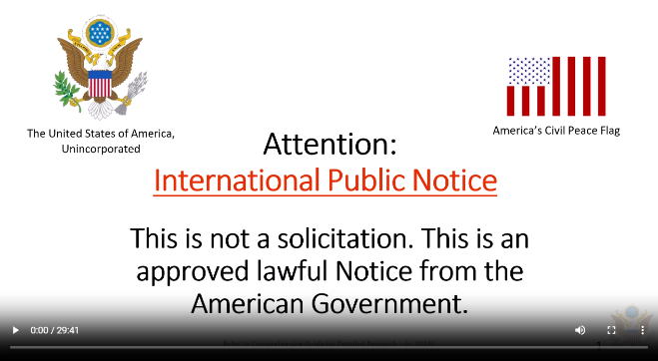
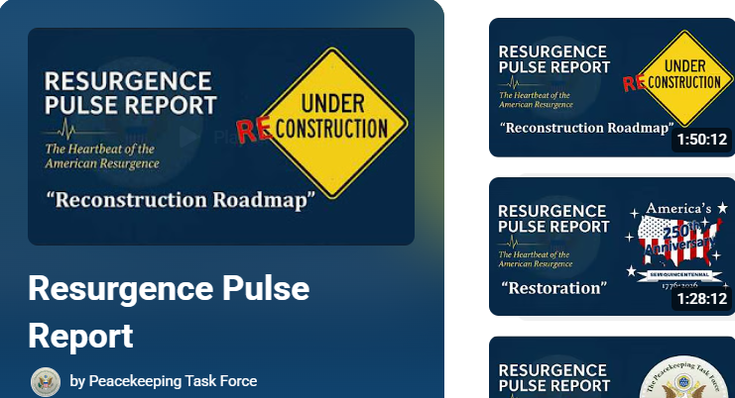
Indeed, these statements are probably difficult for anyone to accept as true. That is expected. So, we have provided the detailed research presenting these facts at this website: https://claimyourinheritance.info/ and on YouTube in The Resurgence Report video series playlist found here: https://www.youtube.com/playlist?list=PLDm8YreJs4BCqBFeqB13tVSQC4sbiZds7.
America has been in this State of Emergency for 165 years. At every year that goes by, we are losing more and more of our sovereignty as American people. Many have taken calculated actions to stop this but with limited success. We need every American to accept the responsibility for this and stop it once and for all.

To end the illegal mercenary or military occupation requires that our de jure government provides America and the world with a competent civilian alternative. Although this task will be daunting, it nonetheless, must be undertaken on a systemic level if we are to correct this grave error completely.

In 2017, our restored de jure Federation of States, The United States of America, Unincorporated, chartered an organization called the Peacekeeping Task Force (PKTF) to facilitate a peaceful transition of our communities out of this State of Emergency toward the restoration of a national civilian government occupation.

The PKTF is providing this Guidebook to assist Americans in taking the necessary action to reinstall our lawfully elected public officials and our sovereign Assembly governments at the town, county and state levels.

We need you to recognize that our federal United States government has substituted itself for our American government without your knowledge. In order to prevent undue and unwanted civil unrest, they can only retreat back into their proper jurisdiction when we, the American people, take our proper place as the de jure government in every town in this country.

This information in this Guidebook will show you the how and the what that needs to be done exactly. The foundational principles contained herein and the bulk of this content are based on the extensive research of historian and Fiduciary for the Federation of States, Anna Maria Riezinger and the Federation’s Living Law Firm.

You are not expected to know what a “de jure” government is, let alone, what is meant by a “republican form of government.” You are not expected to know that the federal United States and The United States are both instrumentalities within our American government’s structure and yet not the same entity. So, in order for you to take on this duty as the ultimate Creators of government, you will need to start with studying the Reconstruction Roadmap of the American Government laid out for you on the following pages.

To understand this map, watch the informational video presented by the PKTF titled Resurgence Pulse Report #8 - "Reconstruction Roadmap" (End of Series 1) found at this link:
https://www.youtube.com/watch?v=KQu2gMsSnzI&t=4994s. It introduces the component parts of our traditional American government as our Forefathers originally established it, the progress that has been made thus far to reconstruct it and the untraveled road that lies ahead of us to completely retore it back to full function.

Consider yourselves pioneers. This has not been done before. The reconstruction of our de jure government should have happened following the end of the “so-called” American Civil War, but didn’t.

So, it is left up to us to roll up our sleeves and do it now. It’s now or never.

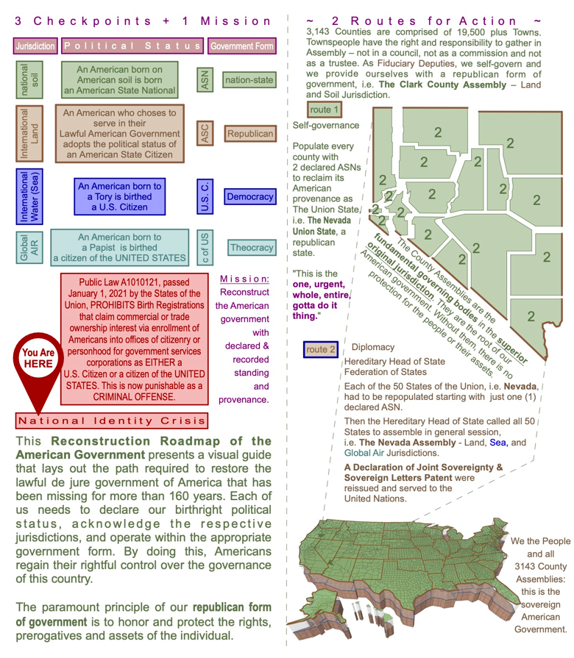
Reconstruction Roadmap of the American Government

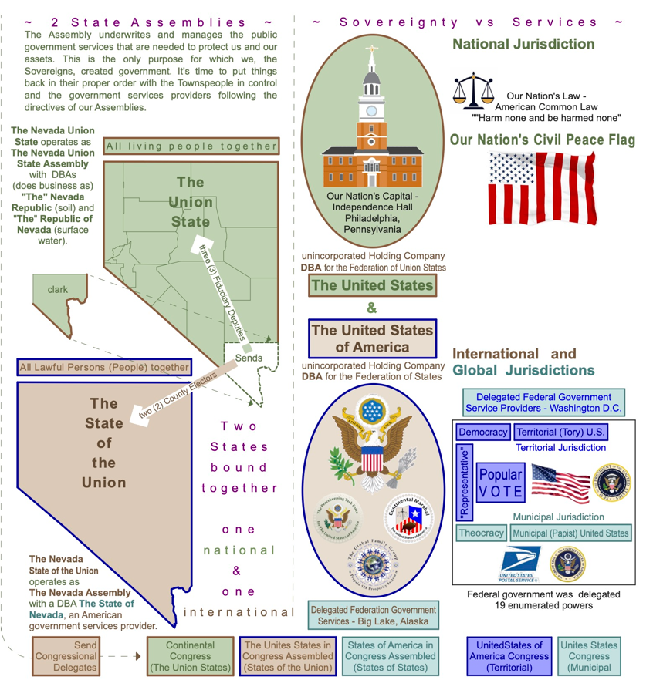
Reconstruction Roadmap of the American Government


Take Away…?

- What year was America placed under military occupation?
- Name the organization responsible for ensuring a peaceful transition to a national civilian government occupation happens?
- Are the United States and The United States the same entity?
- What form of government was America founded upon?
- What has not been going on for 165 years?

