Section 2
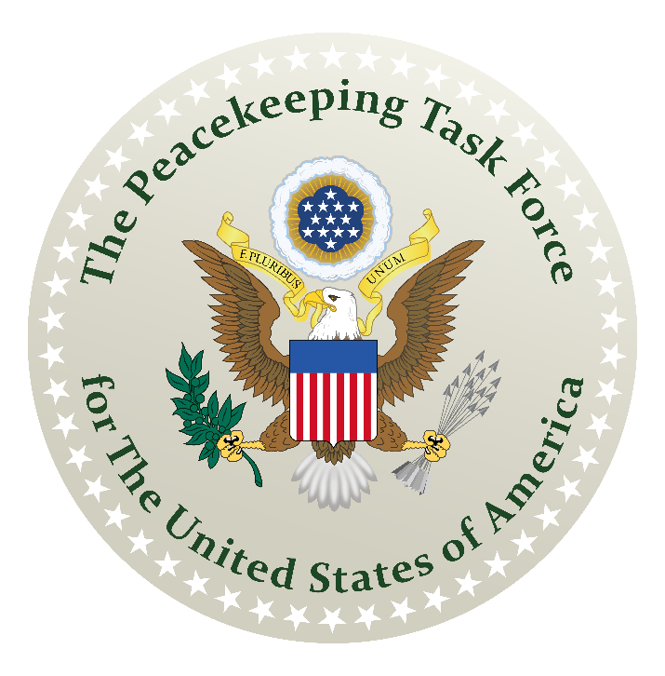
Our Republican Form of Government
How to Assemble the De Jure Government of America
A Guidebook for Reconstructing a Republican Form of Government
An Initiative of The American Government’s Resurgence Project
Prepared by: The Union State Assembling Guidebook Committee

How to Assemble the De Jure Government of America
A Guidebook for Reconstructing a Republican Form of Government
An Initiative of The American Government’s Resurgence Project

Acknowledgements

Thanks to graphic artists Tim

Contents
How to Assemble the De Jure Government of America 1
Acknowledgements 1
Key Points 3
Section 2: Our Republican Form of Government 4
A. What a Republican Form of Government Is Not 5
1. Not a Threat to Democracy 6
2. Not Found in the United States Constitution 7
3. Not a Republic, but a Republican State 8
B. How Our De Jure Government Was Formed 9
1. A Nation of Nations 10
2. Our Unions 10
3. Our Nation’s Official Identity 11
4. Our Hired Hands 12
C. When America Went Off Track 14
1. Origin and Purpose of Municipal Corporations 15
2. Origin and Purpose of the British Crown Corporation 17
3. Our Government Usurped by Corporations 18
4. Your Voting Power Being Used Against You 20
5. Reverted Back to Temporary Government 21
D. Returning to De Jure Assembly-based Government 23
1. The “missing” American Towns 24
2. Townspeople Need to Assemble 26
3. Reinstalling De Jure County Assembly Government 27
4. Electing De Jure County Public Officials 28
5. Why “Unincorporated” Matters? 30
6. Establishing Our De Jure Assemblies In Tandem 32
E. In Keeping with Our True Form 34
Take Away…? 35

Key Points

In Section 2 – Our Republican Form of Government

- The form of government that America was founded upon was called a republican form of government.
- When media and politicians warn us about threats to our democracy, they are talking about the form of government adopted by the Territorial United States service provider.
- During the expansion westward as new territories were formed, they were assigned a temporary government by the Territorial United States government.
- The Northwest Ordinance lays out the process for a territory to become a State of the Union and it guaranteed a permanent, republican government to the newly enrolled State.
- De Jure refers to that which has been established by law.
- More than 350 entities over time went by the name “United States.”
- Americans are electors and U.S. Citizens are voters.
- Municipal corporations are masquerading as governments all across the world.
- The status quo of corporate feudalism will continue if Americans don’t step up and reclaim our birthright nationality.
- A sovereign government structure is unincorporated.

Section 2: Our Republican Form of Government

Common people like you and I created our government by a unanimous Declaration of Independence. We are the sovereign people who hire employees called “citizens” by way of a public election to protect us, our rights and our property. That is the only reason why our forefathers created our unique form of government.

The form of government which they created and that we inherited here in America is called a republican form of government.

With this form of government, it is the individual townspeople who are “free, sovereign and independent” and can act without constraint as long as we do no harm. It is this original sovereignty that we delegated to local assembly-based government bodies to act on our behalf for our own protection. When we do that, we still retain our sovereign powers and continue to direct our assembly-based government bodies.



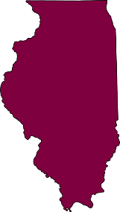
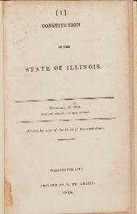
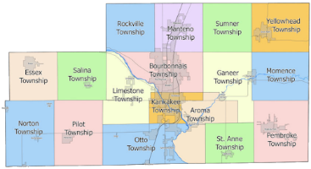
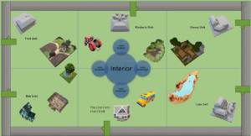


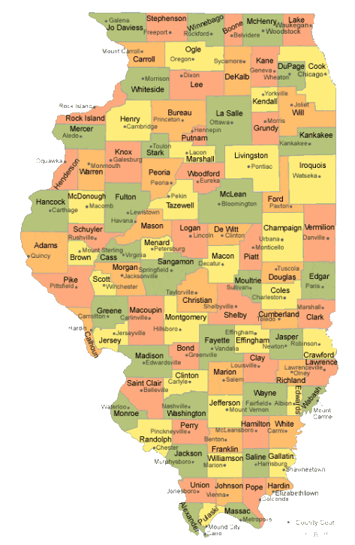
The basic building blocks of our government are each individual living being, then, the family unit, then the local community in which the family or individual lives, then the county which serves them as a local government, then the Union State that serves them at the national level as their nation-state or republican state, then the State of the Union that serves them at the international level, then the State of State business organization that serves them in matters of global commerce.
Farmer
John
Extended Family
Pembroke Community
Kankakee County
Illinois (Union State)
Illinois
(State of the Union) Union
State of Illinois
(Business)
Thus: individual sovereign in their own right > family > community (town) > county > national Union State > international State of the Union > State of State business organization.

Our international State of the Union further delegated some of their sovereign powers by constitutions to federal government services providers.

So, the delegation continued: international State of the Union > State of State business organization > States of America Confederation (Federal Constitution) > 3 Federal Government Services Providers (Federal Branch, Territorial Branch and Municipal Branch)

In 1787 at the time of writing these constitutions, federal simply meant “contract” as in contracted services. When the business organizations show up in this chain, we have left the realm of government and entered the realm of contracted governmental service providers.

Something went wrong over the years and these federal government services providers usurped this entire chain of delegation and interposed themselves as our government. It appears that the employees, i.e. citizens, of the federal government services providers are coming in and telling us individuals what to do and treating us very badly in the process.

It is imperative that every one of us learns where our place was in this chain and that the Constitutions are not the foundation of this country. The Unanimous Declaration of Independence is.

What a Republican Form of Government Is Not

Our government is NOT a Democracy. It’s our Territorial federal U.S. government services provider that’s a democracy. It went by the name, The United States of America, Incorporated. It’s made up of American Tories hired under the service contract called the Constitution of the United States of America of 1789. They essentially serve in our U.S. Military. Their franchise corporations and their employees are always beating that drum and making many people around the world think that the American Government is a democracy— when it isn’t and never was.

In the same way, the Municipal federal United States government services provider is a Theocracy. It went by the name the UNITED STATES, INCORPORATED. It’s made up of American Papists hired under the service contract called the Constitution of the United States of 1790. They essentially serve in federal civil services and sub- political bodies on State, County (Parish or Borough), City and Township levels. They don’t blat that around, because Americans would jolt awake and dimly remember that in our country there is supposed to be a separation between church and state.

Our absent American federal United States government services provider called the American Federal Republic. It also went by the name the United States, Incorporated, but in lower-case style. It was set up as a Roman-style Republic. Their job was to oversee the federal government services from their designated location at the federal capital in Washington, D.C.

Due to our American government’s absence, most people, in error, think that our country is a democracy. A democracy, also known as Mob Rule, is based on majority opinion. To the contrary, the paramount principle of our government is to honor and protect the rights, prerogatives and assets of the individual. My rights end, where yours begin. Our governing law is the American Common Law that dictates “Harm none and be harmed none.”

Each one of our Federal Subcontractors adopted a form of government that was distinctly different than the assembly-based, republican government of the American People.

In theory, this should make them very recognizable, but as we stopped regularly calling our assemblies together it appeared that we had forgotten who we are and that our American Government was “in interregnum” — mysteriously absent and non-responsive.

These were all contracted government services providers and not the government at all. We have blurred the lines by calling them the “federal government.” Nonetheless, we need to get back to our republican, assembly-based government.

Not a Threat to Democracy

Have you heard of the phrase, the “mocking bird” media? Well, listen to this video clip, “Multiple Local News Stations Say the Same Thing Verbatim”:

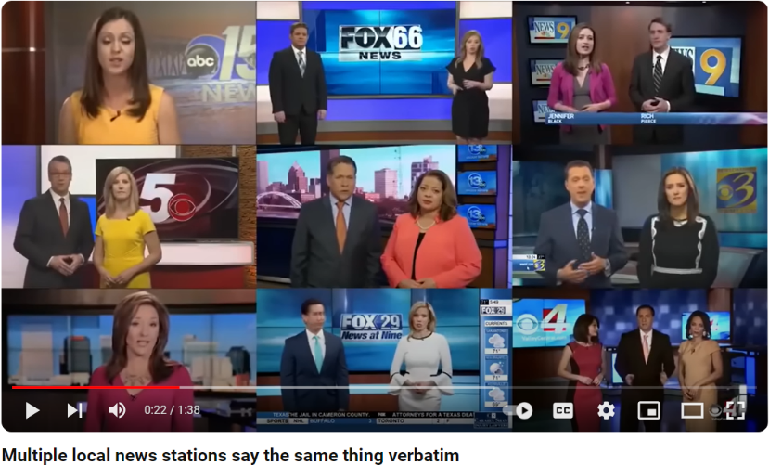
https://www.youtube.com/watch?v=ksb3KD6DfSI

“This is extremely dangerous to our democracy,” says these puppets at the end of this video clip acting like news anchors. Gaslighting in action. They want you to believe that we live in a democracy when our Declaration of Independence guaranteed for America a republican form of government. A democracy is what the British U.S. Government structure operates as.

The problem with a Constitutional Democracy is that if 51% of your neighbors want to eat you for breakfast or steal your home, they can do so—and that is the form of government operating in the Federal United States now.

We, the people, inhabiting the Continental United States are owed a Republican form of government
which upholds the sacred rights of individuals and abhors mob rule. And therein lies the rub.

There was never a competition. The forefathers created our government apparatus to entertain all these forms of government --- republican, Roman-style republic, democracy, theocracy --- and contained them within their respective jurisdictional boundaries. There can be no threat.

By the nature and intent to usurp another’s jurisdictional authority, a competition is artificially and intentionally being created.

Not Found in the United States Constitution

Not only is the news media gaslighting us, but also our educational system is gaslighting us.

The public school did not teach us that the Constitution (of 1787) is all about our deal with King George that effected only our international affairs. It was the concessions made by the States to give up some international control in order to keep full national control of our country.

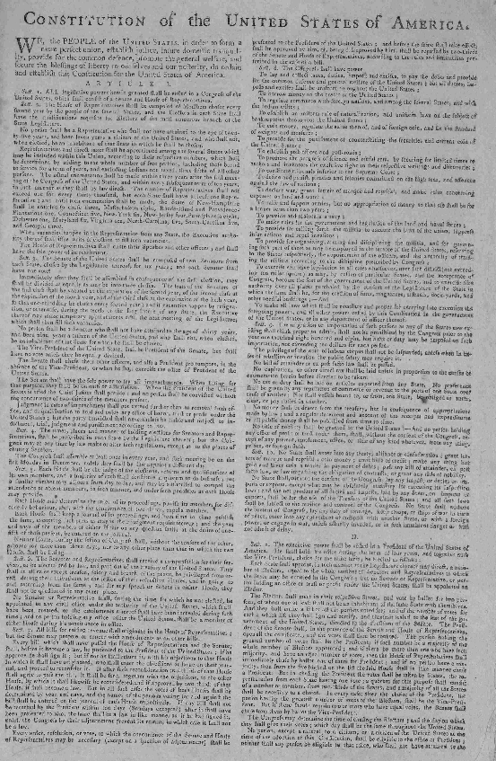
Why, then, would The Constitution talk about our own national state governments operating the land jurisdiction of this country? Or even about the undelegated powers in international jurisdiction retained by the people and the states under Article X?

It wouldn’t and it didn’t.

Any constitutional democracy or constitutional republic that is sought after or promoted is not found in our republican American government. We are not operating under any Constitution. Our governing authority falls under The Declaration of Independence as ‘free, sovereign and independent states.”

Generations of Americans have scoured The Constitution looking for answers on how to fix our broken government, but that is like reading a book about Barn Building, when what we really need to know is How to Raise Cows. The subjects are somewhat related, but only obliquely. Instructions for building hay mows and stanchions and waste gutters give information by inference, but don’t directly instruct us in what we need to know.

So, in Article IV, The Constitution defines the evils of Bills of Attainder and forbids them, and in Amendment VII makes it clear that the American people are owed Common Law Courts, and in Article X it mentions that the states retained undelegated powers not granted to the new United States government, but doesn’t tell us how to object to Bills of Attainder, or which kind of “Common Law” Americans are owed, or give us a list of the powers that the states and people retained.

So far as the writers of The Constitution were concerned it was assumed and we were expected to know all that for ourselves—but somewhere in the mass confusion, deceit, and fraud of the Civil “War” that was provably a mercenary conflict and not a war at all and the Reconstruction Acts---- we forgot.

We forgot who we are, what our states are, what their jurisdiction is, how their powers are exercised, how they are meant to operate, and how to exercise the power of checks and balances. And it’s the same way with our counties. We forgot that the counties are the domain of the people and that the counties in turn control the states.

Not a Republic, but a Republican State

Many English-speakers are familiar with the fact that other languages, including the Romance Languages descended from Latin, and the modern Germanic Languages and Scandinavian Languages descended from Old Saxon, assign a Gender to nouns, so that the definite article for each noun has to be learned along with the word itself.

"Republic" in Latin is a male noun, whereas "republican" is a female adjective describing -- in our important example, "form of government".

The Constitutions --- all three of them --- guarantee us the right to assemble our "republican form of government".

Not a "republic form of government".

This may not seem like a big deal to an English-speaking public, but it is a big deal.

Remember that the Treaties and Contracts including the Constitutions were all finalized in their official versions in the diplomatic language of the day --- French, which is a Romance language derived from Latin, complete with gender issues.

A "republican form of government" is not the same as a "republic form of government" and that should be our first clue that any “Republic” is a different beastie than the government guaranteed to us under the Constitutions.

Thus, in the official diplomatic French version, "republican form of government" refers to "republican states" which are the very same "free, sovereign, and independent states" referred to by King George III in the Treaty of Paris 1783.

There is right now a concerted effort to confuse “Republics” with “Republican States” by the Territorial government service provider and to pass off the “Civil Government” for the “Civilian Government” we are owed by the Municipal government service provider.
Most people in America are not well-prepared to recognize this ruse for what it is, because the study of Latin even in the Church has been suppressed since the 1960’s.
However, there are still a few dinosaurs who do recognize Latin and do have the ability to properly interpret the full one-third of our Founding Documents which are written in Latin. So, it is up to them to clue the rest of us in to the fine points.
What our Forefathers built and what they envisioned from the start was a “republican” state and a “republican form of government”. Please note those two letters “an” that are attached to the word “republic”. In Latin, this converts the word from the male gender to the female gender, and conveys a significantly different meaning than the word, “republic”.
And here we encounter another difference between English and Latin and Latin-derived languages: in Latin (and antique French) small letters denote elevated status or seniority, whereas in English, all Proper Nouns (and though this is something of a grammatical oxymoron, all Proper Pronouns standing for Proper Nouns) are written in Upper and Lower Case.

Thus, in the official diplomatic French version, "republican form of government" refers to "republican states" which are the very same "free, sovereign, and independent states" referred to by King George III in the Treaty of Paris 1783.

In the Latin system, the "state" refers to the national soil jurisdiction formed by the contiguous counties in each physically defined State all joined together, while "State" refers to the international jurisdiction defined by the land underlying the soil and is defined by the physical borders of each State land mass.
With a “republican form of government” everyone in this country has both rights and responsibilities. Everyone has the right to own land and other property interests. Everyone has a duty to uphold the public law. Everyone has a duty to defend our country. Our nation extends down to the poorest and up to the richest among us. We are all equal in our political status, all enabled to elect fiduciary deputies to conduct our public business, all equally protected under the Public Law.
In a “republican state,” the townspeople are organized similar to the present government of the Swiss Cantons.
The job of American governance begins around the kitchen table, which is the focus of power, because the ultimate source of political power in a republican state is vested in the living people and extends outward from the family to the community to the county to the state to the country as a whole.
The living people occupy the pinnacle of power in a republican state and they are what is known as the civilian government.

How Our De Jure Government Was Formed

Our nation-states also called Union States first conceptualized in 1776 as “estates” naturally belonging to the living people, derived from European and Native colonies that existed prior to 1776 and became

sovereign nation-states following The War of Independence.

A Nation of Nations

In the American Government system, all colonies ceased to exist upon conclusion of the peace process ending The War of Independence, and all the living people were set free of any obligation to any European power and have since then been recognized as nationals or dual nationals of their nation-state. Thus, a man born in California is known as a Californian. A man born in Wisconsin is known as a Wisconsinite.
Importantly, a member of the Winnebago Ho-Chunka Nation born in Wisconsin is a dual national under the American Government -- both a Winnebago and a Wisconsinite. This dual nationality system provided for peaceful co-existence and mutual beneficial protection for 62 years between 1776 and 1838, before the European Mischief began again under Andrew Jackson.

- Our Unions

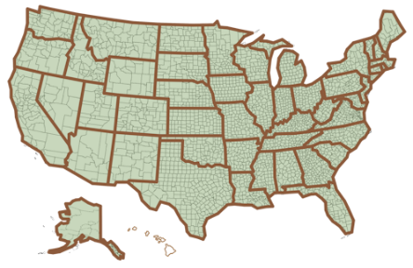
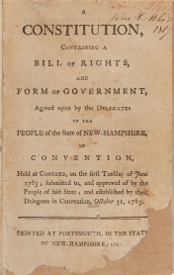
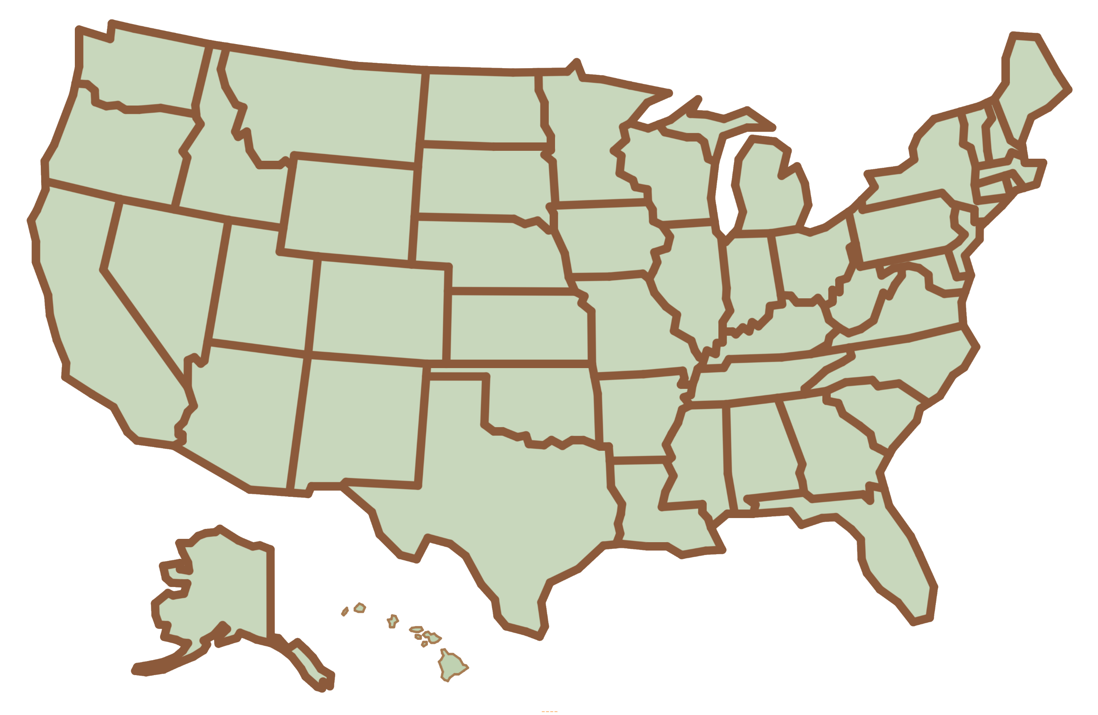
The State of the Union is the international State instrumentality belonging to the people living in the Union State. This is the more familiar State entity by which the Union States typically conduct international business on the land and at sea. When we combine these international States of the Union and they conduct business in their mutual self-interest, they do so as the unincorporated Federation of States known as The United States of America.

Following the States of the Union are The States of States they chartered, such as The State of Wisconsin to engage in interstate commerce.
When these States of States joined together to conduct business on a mutual basis, they did so as a Confederation known as the States of America.
Example: | Latin convention | English convention
Union State | wisconsin | Wisconsin
State of the Union | Wisconsin | Wisconsin
State of State | WISCONSIN | The State of Wisconsin

Thus, we have the Union, the Federation, and the Confederation, all of which were formed between 1776 and 1781, during the actual War of Independence.
The members of the Union are the Union States (soil), the members of the Federation are the States of the Union (land and sea), and the members of the Confederation are States of States (air) chartered by the respective States of the Union.

Our Nation’s Official Identity

When we really delved into it, we found over 350 entities using the name "United States". There were at least four (4) major entities just with our respective government structures that used the name "United States" over time.
The Proper Noun designation of this country as a collective of the Union States together operating the national soil jurisdiction is The United States. This is “the Union” founded in 1776 by Unanimous Declaration.
The Proper Noun designation of this country as a collective of international States of the Union is The United States of America. This unincorporated Federation was founded in 1776-77 by the Union’s nation-state members as a business instrumentality to conduct international business affairs.
Please notice that these American versions of “United States” and “United States of America” include the definite article, “the”, as part of their names: The United States and The United States of America. This is a very, very important distinction. Please also notice that our states-of-states also included the word “the” as a part of their Proper Names: The State of Wisconsin, The State of Florida, et alia, but their Confederation did not include it: the States of America.
The Proper Noun designation of commercial entities operating as States of States and functioning as a collective entity known as the States of America, was also known as the Confederation of States, was founded in 1781 by the Union.
Thus, the three instrumentalities of the American Government are:
- The Union of sovereign nation-states doing business as The United States since 1851;
- The United States of America, our unincorporated Federation of the States of the Union;
- the States of America, our Confederation of American States of States, The State of Wisconsin, The State of Florida, and so on.
These “instrumentalities” are not and never were sovereign entities in and of themselves but instead represent the mutual beneficial combined interests of the sovereign nation-states in various jurisdictions of the law – soil, land and sea, and air.
Having these definitions and identities of the American Government firmly in mind, we are prepared to examine the United States (Federal) Government.

Our Hired Hands

The United States Government is often called “the Federal Government” as if it were one entity, but in fact, it was always three separate government service providers operating under service contracts known as “constitutions”.
There were three (3) original constitutions that were issued to three “essential government services” vendors.
The Federal Constitution known as The Constitution for the united States of America was issued by the States of the Union in 1787 to the States of America, which you can now recognize as the doing-business-as name of the American Government’s Confederation of states-of-states, individually chartered commercial entities engaged in interstate commerce specifically. The entity operated by the States of America to fulfill this service contract became known as “the Federal Republic”.
The Federal Republic was a separate American-operated international-interstate business entity that was run by a special class of citizenry known as United States Citizens; Americans born in one of the nation-states had to undergo a lengthy process of declarations and proof of good character to attain this special citizenship status, as described by the first Immigration and Naturalization Act. Once affirmed, such United States Citizens undertook duties in international jurisdictions that were directly delegated to them by State (of the Union) Citizens, allowing them to provide certain enumerated services and granting them enumerated powers to do the work, related to our land jurisdiction.
You can think of The Constitution for the united States of America as the land jurisdiction federal services contract to which the term “constitutional republic” applies.
The American Federal Republic technically ceased operations as an American controlled entity in 1861, when the States of America Confederation ceased operations because it lost a voting quorum.
Abraham Lincoln, operating as the “President” of the British Crown corporation known as “the United States of America (Incorporated)” secretively replaced the American Confederation with British Territorial Trustees who were American-British loyalists on an “emergency” basis.
The British Crown entity doing business as “the United States of America (Incorporated)” was also a Federal Subcontractor, operating under a second service contract, The Constitution of the United States of America, issued in 1789 by a citizenry called American Tories aka U.S. Citizens.
You can think of The Constitution of the United States of America as the sea jurisdiction federal services contract, covering delegated services in maritime and admiralty jurisdictions on the High Seas and Navigable Inland Waterways to which the term “constitutional democracy” applies.
These British Territorial service vendors were never meant to provide any delegated services related to our land jurisdiction and have never been authorized to represent our States of the Union in this capacity. They secretly usurped against the designated and intended American federal services provider, claimed unauthorized “emergency powers” and made sure not to tell the American People to whom they owed “good faith service”.

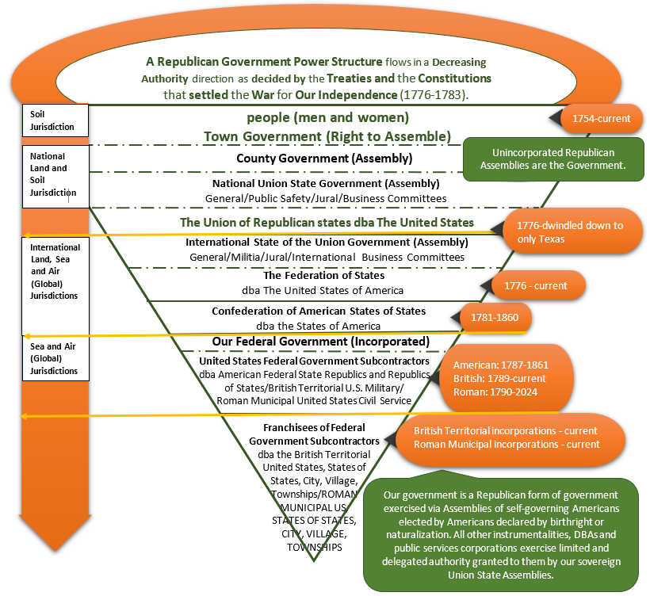
Funnel Diagram Showing Flow of Power
This is where our country went off track and fell back under the influence of foreign powers, specifically, the British Crown corporation doing business as “the United States of America (Incorporated)” and the British Territorial Governments of the so-called “Insular States” defined in their Federal Code as Section 101 A (36) of their Immigration and Naturalization Act--- and otherwise recognized as British Territorial Commonwealths like Puerto Rico that are deemed to be “Territories and Possessions of the United States”.
These British Territorial Subcontractors and their immediate dependents are all U.S. Citizens.
Finally, we get to the third federal services vendor, the Holy Roman Empire, which was granted delegated powers to run specific services, most importantly, the Postal Service, the Patent and Trademark Office, Weights and Measures, and Customs functions of the Federal Civil Service.
The Holy Roman Empire vendors work under The Constitution of the United States issued in 1790.
We are talking about the Union States doing business as “the United States” at that time (after 1851, The United States), handing off enumerated duties to a separate foreign citizenry known as “United States citizens” aka Papists responsible for doing delegated tasks for the Union States in the jurisdiction of the air.
Our government, in its desire to distribute power and in its hope to avoid abuse of power through application of checks and balances, has been rendered too complex for easy understanding and the use of similar names has only added to the problem. Refer to Funnel Diagram on page 13.

When America Went Off Track

By 1720, the "incorporation craze" that had gripped England and Scotland--- a craze created by the members of the Temple Bar and newly organized private insurance companies--- had spread to America.

The opportunity for investors to receive public bankruptcy protection was pitched without the full disclosure that such incorporation transferred ownership interest to the government (and the King or Queen). It inspired a series of mergers and structural changes among investor groups.

The Colonies were among these investor groups. These colonists were not simply European “colonialists” that came to this country. That perception is rooted in a misrepresentation of what historic details really reveals about them. They were companies that incorporated into municipal corporations. Corporations did not recognize the natural sovereignty of living people for they were not sovereign themselves but instruments of Sovereign powers like the Monarchs and the Popes who were in the business of corporate feudalism and profiteering.

These investor groups flooded the entire country not just the eastern seaboard. They didn’t recognize the group sovereignty of the Native Nations who lived here when they arrived to plunder the resources of this so-called “new” world. It was only “new” to the foreign corporate interests for it was already known to immigrants and traders. The situation could not be overcome if not for our political sovereignty having been won by force of arms in the Revolutionary War.

Our country has been misrepresented for decades and preyed upon by our European Allies and Treaty Partners, who are in fact our Subcontractors with respect to everything that has gone on here.
People were being picked off by the British. The British was instigating wars among the Native Nations to divide and conquer their lands and reconstruct them into “States” (really incorporating them into British franchise Territorial States). Our American Government have never been at war with them and never caused them any harm. All such abuses have been carried out by the U.S. Territorial Government. The Trail of Tears? That was the U.S. Government. The blankets infected with Smallpox? That was the U.S. Government. The Reservations? That was the U.S. Government. The racial and cultural genocide? That was the U.S. Government.

Origin and Purpose of Municipal Corporations

Americans made concessions at the end of the Revolutionary War that granted the British territorial custodianship. The development of the infrastructure of the new territories continued through these incorporated investment companies, i.e. municipal corporations, under the management of the federal United States via their Territorial States of States corporations. This is what we are seeing described in the 1875 Supreme Court ruling discussed in Section 1.

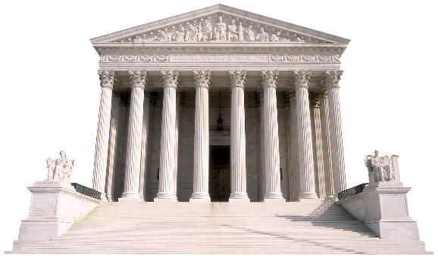
Comm'rs of Laramie County v. Comm'rs of Albany County, 92 U.S. 307 (1875)
APPEAL FROM THE SUPREME COURT OF THE TERRITORY OF WYOMING

MR. JUSTICE CLIFFORD delivered the opinion of the Court.

Counties, cities, and towns are municipal corporations created by the authority of the legislature, and they derive all their powers from the source of their creation, except where the constitution of the state otherwise provides. Beyond doubt they are in general made bodies politic and corporate, and are usually invested with certain subordinate legislative powers, to facilitate the due administration of their own internal affairs and to promote the general welfare of the municipality. They have no inherent jurisdiction to make laws or to adopt governmental regulations, nor can they exercise any other powers in that regard than such as are expressly or impliedly derived from their charters or other statutes of the state.

These municipal body politics are creatures of legislature. None of this structuring is part of our republican form of government that is constituted of people not corporations. The corporations have usurped control over the people and now the tail is wagging the dog.

The word "Municipal" is an adjective describing what kind of "Corporation" we are referring to.

This is the best, simplest definition of "municipality" that we have run across:

"The definition of a municipality is a community with a local government and specified boundaries. This includes towns, cities, or villages. These areas are formally organized by the larger state where they are located. They are given the authority to have their own laws and standards, as long as they are in line with the state's laws as well."

The definition demonstrates that we could call any organized local government a municipality, but in practice, the State of State organizations which have been busily defining "municipalities" always incorporate them as franchises of their own business organization and it is this enfranchisement that enforces loyalty to the parent corporation.

Thus, a municipality owes fealty to the corporation that creates it or the sovereign that charters it, even though it is technically organized and operated by the local people.

A Municipal Corporation structure can be used to organize and administer military services just as well as it can be used to organize and administer civil services, so that is what we have going on here.

What was supposed to happen in the Territorial process according to the Northwest Ordinance, as also discussed in Section 1, is that this “temporary” territorial government put in place by the federal United States government acting as manager of these municipal corporations was to transition control to the once-established “permanent” republican state government owed to the people upon reaching 60,000 “free inhabitants.” The republican land and soil jurisdiction Counties were developed and defined immediately prior to official Statehood was granted.
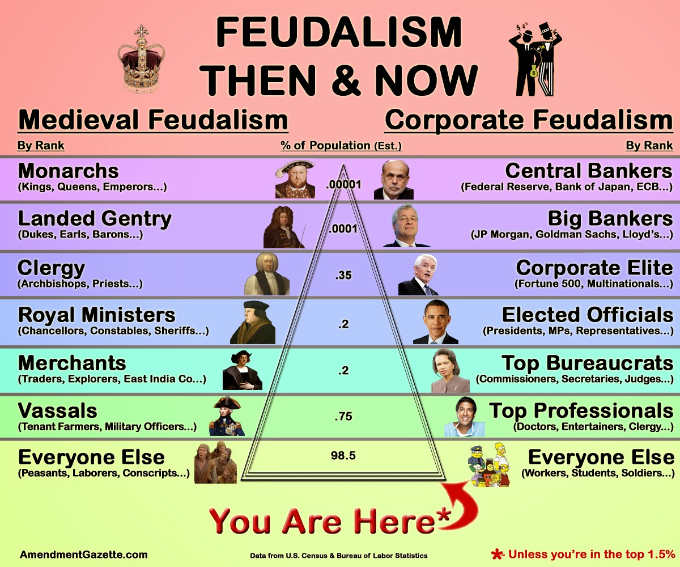
What we are calling our City government, our Township government, our County, our State and even our United States federal government are not true governments but are our government services providers. The municipal corporations today operate as franchises of the Municipal STATE OF STATE franchises of the federal Municipal United States parent corporation which in turn is run under the management of the federal British Territorial State of State franchises of the parent British Crown U.S. corporate franchise. The federal British Crown corporation subcontracted the Municipal corporations to collect war reparations from the Southern Confederate States owed for losing the American Civil “War.”

Our lawful, de jure government had been absent for 150 years and the corporations have run amok. Americans have finally become convinced of this usurpation and so acted to begin reconstructing our usurped American government. Our republican government is actually unincorporated Assemblies and the Federation of our Union States and States of the Union who were originally and still are the true managers and priority creditors of these Municipal corporations serving as our government services providers.

What needs to happen?... Americans need to take our place as the Employers of these government services providers by reconstructing our County and State Assemblies and put these government service providers under our new management. Then the people will indeed be exercising our right to assemble and restore our rights and freedoms that have been long lost to corporate feudalism once again.

Origin and Purpose of the British Crown Corporation

The United States of America Trading Company, a rather obscure investor group in Kentucky, howbeit with support from George Washington and other rich Virginia planters, split in 1732 along class and origin lines, with the British Investors forming the United States of America, Incorporated, a British Crown Corporation, and the more conservative American Investors continuing to operate as The United States of America Trading Company -- an unincorporated American business venture.

This was the origin of both the “Unincorporated” and the “Incorporated“ sides that developed during the Revolutionary War.

The United States of America, Unincorporated, represented the Federation of Thirteen States and acted as the Holding Company for their mutually delegated powers in the international and global jurisdictions.

The British offshoot of the Virginia Company, the United States of America, Incorporated, was given the contract to provide military and Territorial Government functions under The Constitution of the United States of America (1789) to implement the concessions made to end the Revolutionary War detailed in the Treaty of Paris 1783. The Brits ran our Navy on the High Seas and Inland Waterways and provided administration of our Territories and Possessions.

This British Crown Investor Group that invested originally in The Virginia Company and which eventually created the incorporated version of the United States of America quickly got into trouble, and over-extended itself at home in England and abroad. This version of the United States of America, Incorporated, was first bankrupted in the early 1750's, taking advantage of public bankruptcy protection to offload their commercial debts and their share of war reparations still owed to France, which had paid the recovery costs of British Crown investments and war reparations accrued during the Thirty Years War which ended in 1648, basically a hundred years before.

This bankruptcy and default on sovereign debt precipitated war with France.

The American Revolution was, in part, caused by European Monarchs warring with each other and then expecting the colonies to bear the brunt of their sovereign debt for wars and reparations in Europe. This was the corporate feudalism to which the colonies finally said, “No more!”

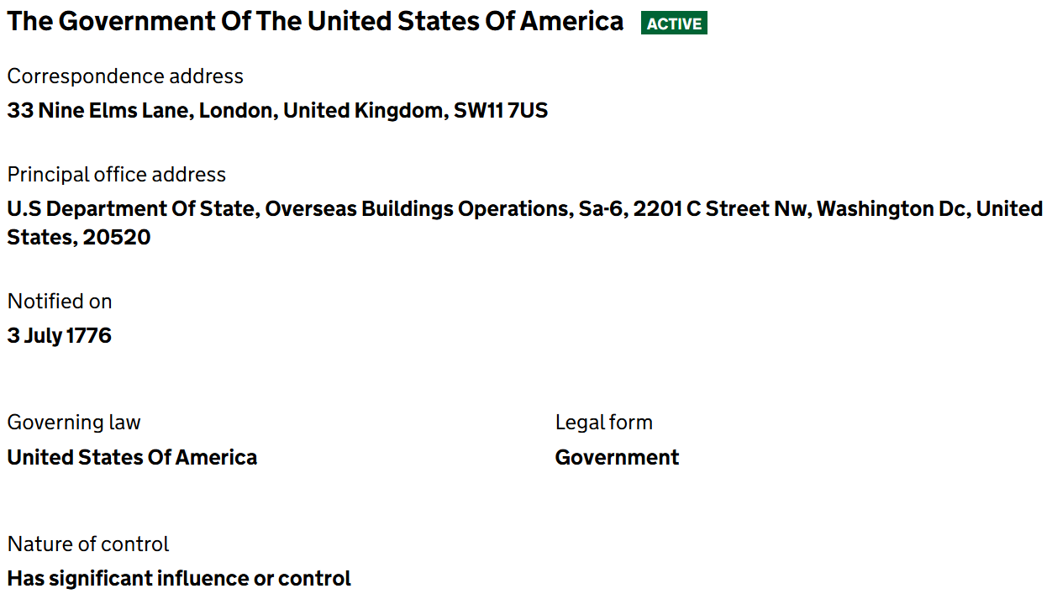
The critical factor that is downplayed in the history books is this “incorporation craze” and how it threatened our nation’s independence from the beginning to the point that our freedom was very short-lived in reality.
The U.S. was always a British Crown Corporation operating from Washington, DC since 1776.

Our Government Usurped by Corporations

Our Federal government was given certain duties – certain functions to perform, which are called powers, but should more correctly be called abilities or services to perform. Those nineteen enumerated services are all in international jurisdiction. There isn’t a single one of them that has anything to do with the land or the people on the land. Our government was set up so that there was this strict demarcation to make sure that the Federal government did not usurp upon us.

What has happened here is that there is not a functioning Federal government. There is, in fact, just a governmental services corporation providing these nineteen essential governmental services as convenient successors to the contract. When you don’t question the change-over then that company that took over can operate on the presumption that they have inherited the contract.

Our Federal Government proper was to be administered and the foreign subcontractors managed by our American Federal Republic that has been defunct since 1861.

Please note. This has been done all over the world. There is no “German Government” just like there is no “United States Government.”

All that exists in 71 countries around the world, are "service" corporations in the business of providing "essential” government services.

All these "Government Services Corporations" masquerading as legitimate governments are tied together by one double-sided parent corporation out of Washington, D.C., a District Territorial government and a Municipal Civil Service Government.

The British Government was so bent on controlling both our commerce which is business between incorporated entities and dominating our international trade policies which is business between unincorporated businesses that after the hostilities of the mercenary conflict aka American Civil “War” ceased, they usurped against all our National-level States of States aka Confederate States, which we historically referred to as the North and South, and moth-balled them, pending their “Reconstruction”, and rolled over all their assets into State Land Trusts operated under names like the “Nevada State”.

This gave the appearance that since our National-level States of States were no longer operating in the international jurisdiction of the sea, that our government as a whole was “in abeyance” and being “held in trust” pending “reconstruction” and that is how the perpetrators of this massive criminal fraud scheme have presented the situation to the rest of the world for the last 150 years.

They next imposed upon the sovereign States and engineered the writing of new “State Constitutions” which, undisclosed to the people, were not rewrites of the existing National-level State of State Constitutions, but were instead completely new constitutions allowing British-backed Territorial-level State of State organizations to take over and control everything.

By doing so, they essentially threw us back into the status of a Territorial possession of the British Crown.

The National-level States of States doing business as, for example, The State of Nevada, were secretively replaced by Territorial-level States of States doing business as “the” State of Nevada, Incorporated but they conveniently leave the “incorporated” part off. These you will find registered with a DUN and Bradstreet number as government services corporations.

The names were deliberately and deceptively similar so that to Joe Average nothing appeared to have changed. There was a State of Nevada doing business before the “war” and a State of Nevada doing business afterward and they appeared to be the same, albeit one was authorized to act in behalf of the actual land jurisdiction State of the Union and one was a foreign, British- backed, unauthorized usurper.

This is in complete Breach of Trust, Fraud, and Violation of Commercial Contract, and it is what must now be addressed by the American People and the sovereign land jurisdiction States of the original unincorporated Union of the States doing business as The United States of America.

The aim here is to restore and empower our “missing” National-level States of States to their rightful power and position, enabling them to act in behalf of the actual land jurisdiction States, re-vesting all assets held in the State Land Trusts back to the actual States and people.

That is, the assets held by the Nevada State trust, for example, must be re-vested to Nevada, and the original National- level State of State doing business as The State of Nevada must re-vest to take over the bankrupt Territorial State of Nevada and the liquidated (as of October 2024) Municipal STATE OF NEVADA assets as the Priority Creditors and Holders in Due Course.

Both The United States of America, Unincorporated, the Federation of the sovereign States, and the sovereign land jurisdiction States individually are still operating and still standing peaceably on the land they are heir to. All assets of the Nevada State belong to Nevada and are not chattel backing the bankruptcy of any Territorial State of Nevada or any Municipal STATE OF NEVADA presumed to exist. All assets of The State of Nevada likewise belong to Nevada despite immoral and despicable British meddling in our national affairs under conditions of Breach of Trust, deceit, fraud, and fraudulent claims of “war” and unauthorized, emergency powers.

And now that we have that clear, The United States of America, Unincorporated, the Federation of the sovereign States, has directed the international bankruptcy trustees to return the assets held in trust by all their Territorial States and their Municipal STATEs back to the sovereign State of the Union Assemblies and the people, while the people are busily restoring their County assemblies and their Union States with their State Republic dbas.

Your Voting Power Being Used Against You

You have believed that the "federal government" was your government, but in fact, it has always been a foreign service vendor operated by British Subjects here on our shores to provide "essential governmental services". It's the governmental services equivalent of Exxon.

Read Article IV of The Constitution.

You have elected all these jokers in good faith, assuming that you were electing them to public office. They have occupied similarly named private corporate offices instead, and left the public offices vacant.

Read the Foreign Sovereign Immunity Act (FSIA) and the International Organizations Immunity Act (IOIA) for blatant proof of what they have done.

You thought you elected Fiduciary Deputies to conduct your business in Congress, but no, they redefined their role to be mere "representatives". They then "represented" you any way that padded their pockets and boosted corporate profits.

See their Amendment to their phony corporate "Constitution" published in 1868 that changes the accountability of "US Senators" making them only accountable to their peers in Congress. Being a Senator is as close to being "king" as it gets. They can't be recalled by the people who elected them. And you have allowed all this crap, because frankly, you and your parents and grandparents have been asleep at the wheel.

Go back and read the actual founding documents --- the Definitive Treaty of Peace, Paris, 1783 spells it out. The Constitution is indeed the implementations of the Treaty. It speaks of two populations in this country and there always have been: "free, sovereign, and independent people of the United States" and the British Subject "inhabitants" loyal to the King, here on our shores to provide "essential government services".

The same treaty reveals that King George III remained the acknowledged "prince" and Arch-Treasurer of the United States after the Revolution.

Your States of the Union were its original customers. They agreed to receive and pay for nineteen strictly enumerated services spelled out in The Constitution----all of them carried out in the international jurisdiction of the sea.

But corporations being corporations, they've drummed up business however they saw fit, often via extortion (IRS) and racketeering (Social Security, Obamacare, etc.) and theft (BLM).

The agents of the "federal corporation" routinely lie to you and tell you that you have to buy something or pay something or take some action (like signing up for Social Security) because it is a "government mandate" and you are stupid enough to go along with this, so they continue to get away with it.

They routinely criminalize normal activities of common right, like traveling from Point A to Point B or getting married, so that they can charge you for "licenses" and "regulate" your private business as "commerce". They consider all "United States Citizens" their slaves and all "citizens of the United States" are defined as criminals.

Read the 13th and 14th Amendments of their bogus corporate "Constitution" more carefully and you will see what has gone on.

In their 13th Amendment they abolished slavery---- except for criminals. In the 14th Amendment of their filthy look-alike, sound-alike corporate charter document, they made all "citizens of the United States" criminals. By definition. And then they have contrived to define all of us as "citizens of the United States" by any means fair or foul.

We have gotten way off track and have played unwitting host to the most vile, venal, oppressive, out of control crime syndicate in the history of the world, and we have mistakenly thought that this THING was our own dear government and paddled along like good little ducks, acting in good faith, doing whatever we were told.

You have been duped to think that your voting power applied to their rigged system is the only way to put America back on track. To get you to believe this, you have been successfully blinded to the word “rigged” and even so, since 1776.

Reverted Back to Temporary Government

Following the American Civil “War,” a State of Emergency was called and everything reverted back to a Temporary government pending a complete reconstruction of our Republican states.

We have to go back to 1860 to realize how this happened.

After President Abraham Lincoln, president of the British Territorial U.S. government, declared a State of Emergency following the coup orchestrated by the U.S. Miliary acting as a mercenary force for the British Crown, they reinstituted temporary United States government franchises in every State obligating each
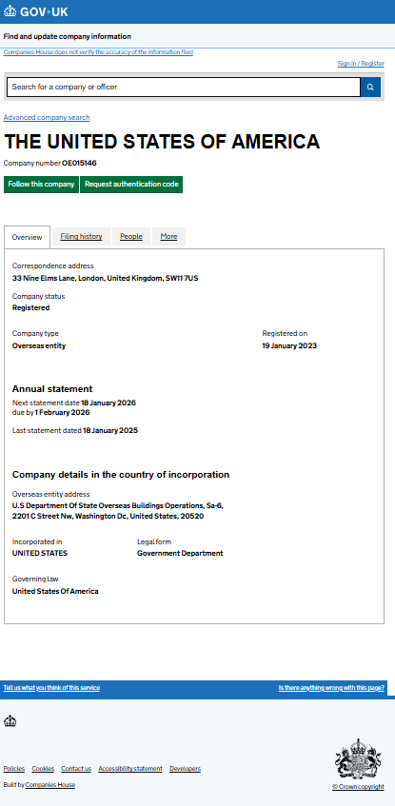
State to sign a Territorial State Constitution since the American Confederate State franchises were bankrupted by Lincoln.

The actual issues facing our country and our world result from rogue commercial corporations --- specifically, Municipal Corporations, managed by Territorial Government interests, being allowed to run wild and commit crimes with impunity.

Obviously, our American Government predates any service contracts established for our Federal Employees by the Constitutions, and it is our American Government --- the government of the nation- states of The Union --- that acts as the Principal Party agreeing to the Treaties and their implementation via the Constitutions adopted in 1787, 1789, and 1790.

Both the problems and the solutions thus lie at an entirely different level of government, and concern us, the American People, not our Federal Employees who have been misdirected by their foreign Principals for the better part of 160 years.

We are the Aggrieved Parties whose trust has been grotesquely violated by these Federal Employees, the Primary Victims of their frauds, their Priority Creditors, and the Principal Secured Parties owed the assets they've purloined.

Apparently, everyone forgot that the Pope owns and operates all these Municipal Corporations, and that he is responsible for liquidating them when they are caught committing unlawful acts against the interests of living people.

That is the quid pro quo and standard treaty agreement allowing the Vatican and the Roman Curia to create all these Legal Fiction Entities and to profit from them in the first place. Under Ecclesiastical Law, they have to liquidate the whole mess upon demand.

When you back-track through the infinite maze of interlocking trusts and municipal corporations affiliated through the Swiss BIS and the Global Federal Reserve Banking System and all the rest of the corruption you find that the final Rat Hole is "the United States of America Corporation" DUNS 16-190-6193.

Returning to De Jure Assembly-based Government

Only you and your neighbors joining together and learning to operate your own government are capable of forming and preserving the de jure Republican state governments we are owed. What we have posing as government in America are Municipal corporations not Republican state governments.

Remember the 1875 Supreme Court ruling, Comm'rs of Laramie County v. Comm'rs of Albany County, 92 U.S. 307, determined that the State is the superior power and creator of the County and that these bodies are actually municipal corporations, the smaller body, the County, being a franchise of the larger body, the State.

This is completely opposed to how our de jure government was structured.

In the world of wo/men, we established our sovereign nation-states, known as the Union States, as a consequence of our own natural sovereignty. Then we delegated powers to the Union State to conduct the business of the people in our towns and counties.

When you stand up and build your towns and then the counties you are building towards building the Union State of your State and then forming your State of the Union.

The realms of land and soil exist in perpetual union as a fact of nature, so that the sovereign Union States abide in eternal joinder with their States of the Union, with the Union States directly presenting the government of the nation-states – our national jurisdiction, and the States of the Union representing the Union States in international jurisdiction.

Only the people and their nation-states have sovereignty; all the rest of these instrumentalities only "represent" that sovereignty to different degrees and in different jurisdictions.

The Union States and the States of the Union still remain to this day.

As the Americans "returned" one by one to the land of this country, they repopulated the Towns, Counties, and Union States and they also, at the same time, repopulated the States of the Union.

The “missing” American Towns

In America today, we have no American Towns. For proof of this, take a look at your local election ballots.

Take a look at this sample ballot on page 25 of a local Town’s elections. This is proof of the “rigged” system and how your voting power is being used against you.

To qualify as an American Town, we need declared Americans populating them. Right now, they are populated mostly populated by Tories and Papists making them akin to “colonies.”

This ballot shows that you are voting for “public” officials of a Municipal City corporation and “public officials” of a Municipal Township corporation. What you need to know is that any word to which “ship” is attached refers to the sea jurisdiction that is predominantly overseen by our British Territorial government services provider, not the land and soil jurisdiction that is overseen exclusively by your American government.

A county, or parish for Louisiana, or borough for Alaska, may have townships, villages and/or cities. We have over 19,500 towns in America. None of them American. These are smaller political subunits within the county that often have their own Town Halls or City Halls and these may be reorganized to locally select delegates to serve on the County Assembly, or not. It just depends on how the local townspeople within the county, structures itself and how Assemblymen are chosen.

This ballot shows you why and how your vote is “rigged.” Did you know that you were acting as a voting member of municipal corporations as a shareholder and not as a free, sovereign American acting as an Elector? There is no way to get to freedom from here --- from the status of a voter.

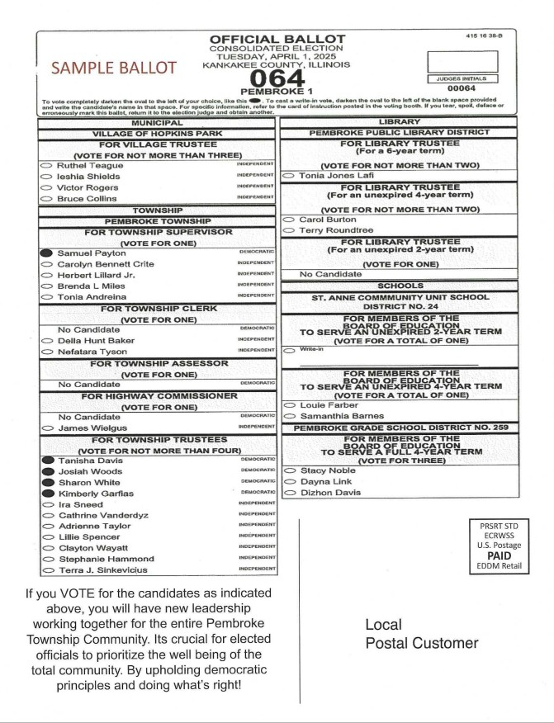

- Townspeople Need to Assemble

The American state national living on the Town gives a 30-day Notice and announces a public meeting of the unincorporated, soil jurisdiction Town meeting. This is what you already know as your Annual Town meeting.
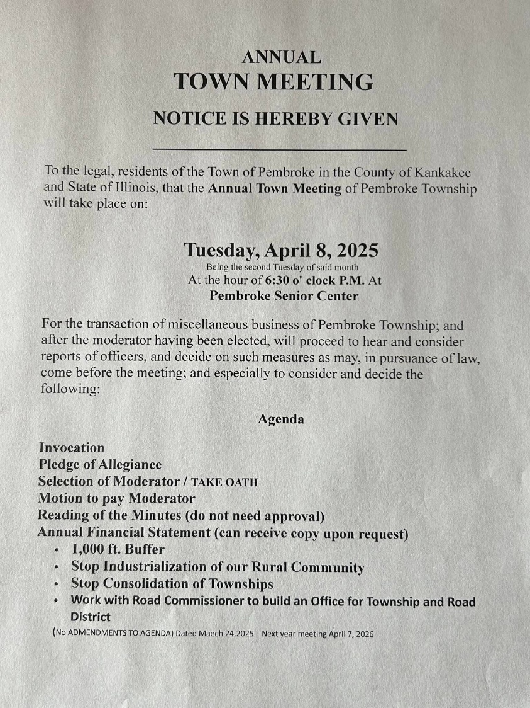

But instead of meeting as enfranchised U.S. Citizens in the “Town of Pembroke” in the “County of Kankakee” and “State of Illinois” --- corporate municipal organizations on paper --- you must declare your birthright nationality as an Illinoisan, for example, then assemble on Pembroke Town on Kankakee County on Illinois. We are physical people domiciled on the physical land and soil of our States as owners and custodians and our Assembly governments are unincorporated.

At these town meetings, the people living in those townships and cities can choose to continue to run your township, city or county as an incorporated franchise of the Federal government services providers to provide yourselves with governmental services and let anyone serve as your “Public Official” --- OR you can decide to assemble yourselves as a Town Assembly, foreswear federal kickbacks in favor of freedom from federal taxes, debts, and regulations, and run your own local government at both the township and city levels by sending deputies to convene your local County Assembly government.
The people convening your Town meetings must provide proof of your declared birthright nationality or adopted political status recorded and published on the public record. Proof of renouncing any United States or other citizenship and claiming back their political status as Nevadans, for example.

You are now free of any presumption of voluntarily acting as U.S. citizens or as citizens of the United States. The Townspeople emerge as the Priority Creditors and Underwriters of both federal United States corporations and all Territorial States of States corporations and all local Municipal franchise corporations such as the County of Clark, the Las Vegas Township and the City of Las Vegas.

You are free men and women attending to the business of your own Town, acting through a lawful Town Assembly, if the townspeople so choose this organizational structure.

It should now be clear just how vital your participation in your own local unincorporated Assembly government is, and how that participation or lack thereof impacts every aspect of your daily life.

It is for this reason and this reason alone why you have not experienced any significant change in your rights and freedoms in your daily lives. You have not organized your own local de jure American Assembly government.

This makes clear how important your political status is. As a United States citizen you are “presumed” to be a federal corporation employee. As a “citizen of the United States” you are presumed to be a slave owned by the federal municipal corporation doing business as the “United States”.

Unless you are actually employed by the federal government as a military or federal civilian employee, why would you ever claim any status of United States citizenship otherwise, subject to federal Territorial and municipal laws? Unless you were truly desperate for political asylum or other aid of some kind, why would you ever agree to be considered a slave and chattel owned by the United States, Inc.? Nobody in their right mind would knowingly and willingly choose that fate instead of wanting to be a free man. Did you?

Reinstalling De Jure County Assembly Government

Your Mission is to reclaim your stolen identity as a national of your nation-state, to assemble your County and State Assembly governments and finish the Reconstruction that should have happened after the American Civil “War.”

The assembly is the established structure that Americans use to organize our government where the primary work of government gets accomplished via committees.

Our republican form of government is provided by the county level local government occupying the soil jurisdiction and is created when, and only when, people claim their birthright political status and join together to create a County General Assembly.

The Counties are the Supreme Local Government within their physical borders. The actual County is run by a County Assembly -- not a "Council", not a "Commission" --- a County Assembly such as the Clark County Assembly.

County Councils are part of the Territorial Government which more specifically is a type of government service provider of some of your local public services.

Commissions are part of the Municipal Government which more specifically is another type of government service provider of some of your local public services.

You are "none of the above".

You are the Third Man Out. You are not incorporated. You are, nonetheless, the actual Government.

County Assemblies are formed by people declaring and acting in their birthright political status as Americans.

Not British Territorial U.S. Citizens. Not Roman Municipal "citizens of the United States".

So those professed so-called Interim governments, Jural Assemblies or Committees of Safety members and the like who organized themselves decades ago must be able to show that their Counties were formed by declared American state nationals in order for our Federation to recognize them as the de jure Assembly government for that County and release public funding to them.

Counties are defined by its geographical borders. It is a recognizable land mass. The American people living within its borders make up its Assembly. There is only one Assembly per county in America, by definition.
So, County Assemblies, wherever you are out there, contact your State of the Union Assembly so they can verify your standing and provide your information to the Fiduciary’s Office. First in time is, first in line.

Like every other county in America, let’s take Clark County for example, it is ultimately and actually owned by the people living on Clark County. You get to decide whether or not to continue operating your County government as a federal franchise or not.

Your unincorporated body politic gets to assemble itself whenever an American state national living on Clark County gives a 30-day Notice and announces a public meeting of the Land and Soil Jurisdiction Clark County Assembly convened under the authority of the sovereign Townspeople who elected them.

Electing De Jure County Public Officials


In our republican system, we elect as the landowners acting as Electors in government. We do not vote as shareholders of corporations. Both are held as “public elections,” but one “public” is Americans and the other “public” is federal U.S. Citizens.
Elected Sheriff Andrew on Richland County, Ohio; Elected Sheriff Adam on Summit County, Ohio, Elected Sheriff Annette on Marion County, Florida on Restore the Republic Podcast Christmas Special December. 23, 2025.

The County Assembly is enabled to elect its own Sheriff to serve the land and soul jurisdiction county, to uphold the public and organic law of Nevada and the United States of America. He is then the top peacekeeping officer on the County. He outranks – by far – all the hired police, all the detectives, all the commissioners on the incorporated “County, Inc.” payroll.

The actual County Assembly can also elect its own Justices of the Peace and its own Court Clerks and its own Bailiffs, Coroners, and other court officers.

Our Ancestors were determined that no king or government was going to control their lives again, so they made the County the fundamental political unit and supreme political jurisdiction in the American Government.

There isn’t a corporation anywhere, inside or outside of the borders of any County, who has a right or a word to say otherwise, because within the borders of the County, the actual unincorporated County Assembly holds the absolute power of self-determination for that county and the people living on it. They can purge and pitch any law or statute put in place by “County, Inc.” and they can choose to dissolve County, Inc. and put an unincorporated business that is under their direct control in its place.

Strange but true, the County Sheriff elected by the jurors is the top Public Law Official in the country. Within the physical boundaries of his County, he is the embodiment of the Public Law and its chief enforcer.

Because he works for the soil jurisdiction, the actual County Sheriff is a "Peacekeeping Official" and not a "Law Enforcement Officer". See the difference?

Peacekeepers work for the people, the land and the soil. Law Enforcement Officers work for "persons" meaning the corporations and their shareholders operating as incorporated States of State, like the "State of Ohio".

We have been well and thoroughly confused and duped into thinking that their "County Sheriff" is our "County Sheriff", when in fact an unlawful conversion has taken place.

Many of those operating our Counties back in the 1960's took the bait of "Federal Block Grants" and elected to incorporate the unincorporated Counties they were working for.

In doing so, they unwittingly removed and converted the actual County Government into mere commercial corporations operating as franchises --- like Dairy Queen franchises of Territorial and Municipal corporations.

They handed over our sovereignty "for us" in exchange for racketeering kickbacks.

Ironically, we are fortunate that those same people who voted to unlawfully convert the Counties were already unwittingly functioning as incorporated "persons", so had no authority to give away our Counties. They were merely employees of ours at the time already being unlawfully converted into enfranchised federal dual Citizens themselves via their birth registrations.

They had already "vacated" their natural capacity as unincorporated Jurors and Electors.

Many Counties tried to have it both ways and kept the unincorporated County running and simply set up a corporation calling itself something similar -- like, "The County of Jackson" instead of "Jackson County", so that the offered federal kickbacks could be laundered through "The County of Jackson".

This set up a situation where County Officials were, for a time --- and some still are--- posing to operate in two separate capacities. The Sheriff supposedly “elected” to the unincorporated soil jurisdiction office simply put on a different hat as the occasion demanded, and functioned as the "Sheriff" of the incorporated "County", too.

But our ancestors set it up so that no man can serve two masters.

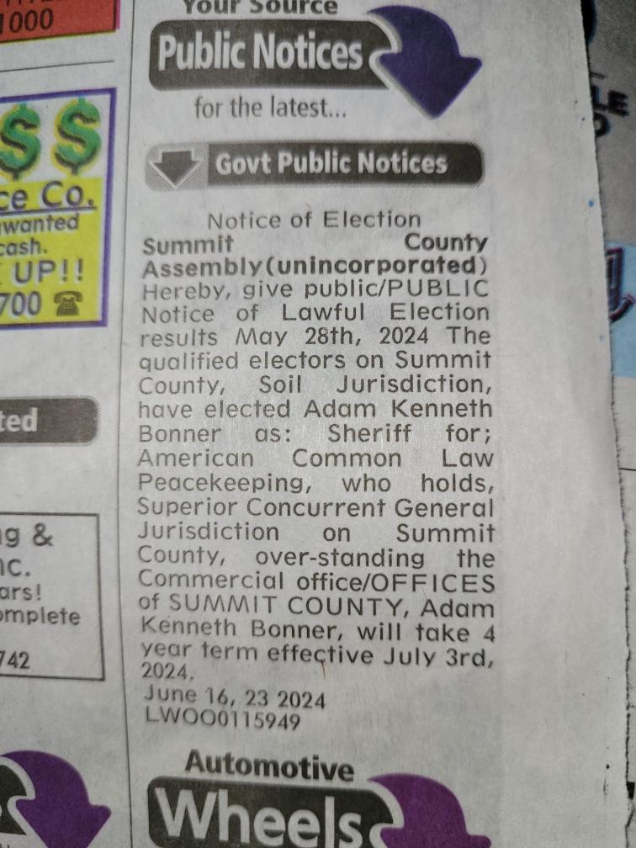
The problem is that our actual Counties are political subdivisions of our States and they occupy an entirely different jurisdiction --- that of the land and soil -- which does not recognize or tolerate any form of "Dual Citizenship" at all being both Territorial U.S. Citizens and Municipal citizens of the United States.
Legal Notice of the election of Sheriff Adam in a local Summit County newspaper, June 2024.

The land and soil jurisdiction of this country does not allow us to operate in incorporated and unincorporated capacity at the same time. It's one way or the other.

Either you operate as the actual Sheriff of the unincorporated County and State, or you operate as a "Sheriff" of an incorporated "County" franchise of a State of State. See the difference?

There is a Macon County Sheriff working for Georgia, the actual State, and then, out of the blue, there is suddenly a "County of Macon" and the "Sheriff" of the "County of Macon" is working for the "State of Georgia", instead.

Sleight of hand. Presto-Change-O! One minute you are standing on the land and soil and your County Sheriff is your County Sheriff, and the next, he is a patsy working for a foreign corporation. Go figure.

Why “Unincorporated” Matters?

Using Clark County as an example, the Clark County Assembly is different from the corporate version of “Clark County, Incorporated”. The Assembly is the actual Government Body Politic as opposed to a “representational” body who simply provides you with governmental services.

Instead of handing your proxy to an agent elected to act in your stead as a member of the Board of Directors of Clark County, Inc. calling himself a “Public Official”, the people have the absolute retained right to conduct your own business and to bypass the use of any agent to do your business. It’s the difference between sending your servant to town to conduct your business for you and doing it yourself.

Whereas anyone can be elected to serve as a “Public Official” for Clark County, Inc., including lawyers and US CITIZENS, not just anyone can be a member of the actual Clark County Assembly.

The actual unincorporated Clark County Assembly is composed of American state citizens and the unincorporated State Assemblies of the Union State and State of the Union are composed of American State Citizens from the unincorporated Counties on Nevada. They have to be either natural born or naturalized Nevadans and they have to be claiming that political status in order to be elected to the actual, unincorporated de jure Assemblies.

The people properly claiming their birthright political status are then enabled to crack the whip and tell the members of the Clark County, Inc., for example, what to do and how to do it, and can even tell the “Public Officials” elected to serve on the board of Clark County, Inc. to dissolve Clark County, Inc. and resume operations as an unincorporated county.

So, in actuality Clark County, Inc. is a governmental services provider not a government at all.

If the Clark County Assembly decided to dissolve them, it would mean an end to federal corporation kickbacks, but it also means an end to federal taxation and federal debt obligations, federal regulation and corruption in general.

Not all counties in the country are "incorporated" --- meaning that some of them didn't take the bait of Federal Block Grants in order to maintain their independence. We are finding that MOST counties fit in this group and did not specifically or publicly adopt being incorporated. Like the rest of us, they were apparently told "you have to do this" by Federal Agents, so they changed the Style or Ordering of their names and unwittingly created new corporate Persons that were assumed to be operating as Federal Franchises.

There are 3143 counties in America according to google and people living in all of them. You all need to do some research into your own county’s history to find out the actual status of your county government. Most likely, the British Territorial State of State franchises simply "moved in" after the mercenary conflict aka American Civil “War” and have operated like cuckoo birds in a robin's nest ever since.


Do you get that analogy? Do you know what cuckoo birds are known for? Cuckoo birds are best known for brood parasitism, a behavior where they lay their eggs in the nests of other species, leaving unsuspecting foster parents to raise their young.
By the use of something behaviorists call supernormal sign stimuli, they con wrens and other small birds to incubate their eggs and rear their young for them, while the host’s own young suffer or perish. (Quora)

Now while the incorporated counties are receiving "federal block grants" --- those "block grants" are the result of federal corporation racketeering and pillaging carried out against your own assets, your own people, your own businesses, and your own land. You are funding your own misery and demise.

As long as your county takes this bait and operates as a corporate franchise it has no standing and no credibility as any part of our legitimate government. It's just a governmental services provider for hire, like Mike's Security Service or Fast Eddie's Carpet Cleaning. And it is the same way with the State government.

Establishing Our De Jure Assemblies In Tandem

We have 2 Land Jurisdiction State Assemblies to reinstall. They are the national Union State Assemblies and the international State of the Union Assemblies.

We have 2 Soil Jurisdiction Local Assemblies to reinstall. They are the American Town Assemblies and the County Assemblies.

How can we accomplish this expeditiously and peacefully?

Your job and my job, our job, if we should choose to accept it is to reconstruct them all “at the same time.”
This is the Peacekeeping Task Force (PKTF)’s proposed strategy looking at this from a 30,000-foot view. And yes, we know. It sounds like a mission that’s impossible.

The PKTF has been looking at our transitioning competence and has observed what has been tried in the past. We have noticed what has worked and what hasn’t to arrive at this determination. In order for a transition from de facto to de jure government to happen peacefully and competently, the reconstruction of the de jure Assemblies must take place in both jurisdictions, land and soil, “at the same time.” Taking this approach aligns with our principles of our American Common Law and our republican form of government where the people rule from the bottom up.


A tandem bike is a bicycle built for two or more people who pedal together, featuring roles split between the front captain who steers and brakes and the rear stoker who helps power the ride.

We have observed the strategies proposed throughout the years:
In 2015, our Federation’s Fiduciary Anna proposed…
Quote: “Reorganize the government of the Continental United States beginning at the Township level and working your way up to the State level. You have more civil authority on the land than the entire federal government. Exercise that authority. Let the rest of the world know what has happened here.” Unquote.

We observed in 2021, our Federation’s officer, Harold, admit during their Federation Support Project discussions:

Quote: “The Federation threw up its hands a long time ago and said, you got to be kidding. There's over 3,000 counties. How the devil are we going to deal with that? We have enough trouble with 50 states.” Unquote.

Then the Fiduciary’s perspective shifted as we observed in 2024 to take a different strategy:

Quote: “the primary goal is now and has always been to organize and get the States standing FIRST” Unquote …. Quote: “You DO need to organize your State Assembly first but there is no reason you can’t develop the counties in tandem.” Unquote.

Not a first, a second, then a next approach will work. Our republican government structure works from a basis that the jurisdictions are interdependent although autonomous, with the soil jurisdiction directing the whole show by its delegations of powers.

When you take notice that historically, the soil jurisdiction “people” are the same land jurisdiction “People” who just stepped up to serve in an additional capacity, then it doesn’t seem like a mission impossible.

We need 2 County Electors to present the voice of the people in the international land and sea State Assemblies, called for example The Illinois Assembly. And we need 3 Fiduciary deputies from each County to present the financial interests of their Counties at the national land and soil State assemblies that we call, for example, The Illinois Union State Assembly.

So, you can see the logical progression of how our republican form of government was built, and how it makes perfect sense to reconstruct our republican assemblies “at the same time in tandem.” That’s how the PKTF proposes that we strategically do this.

Watch Video: Resurgence Pulse Report Episode 6: De Facto to De Jure
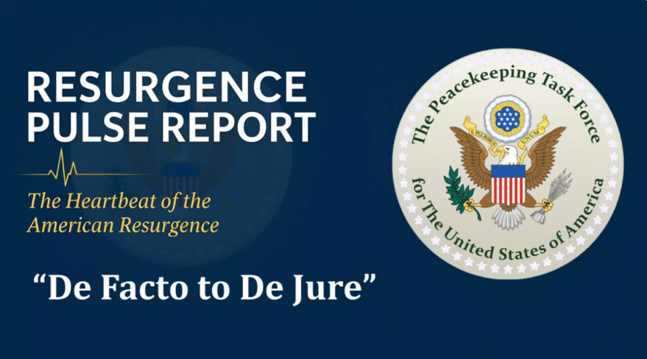
https://www.youtube.com/watch?v=VCAIH4Fe970&t=31s

In this way, we waste no one’s energy. We waste no one’s time invested. We leverage and maximize our efforts to our advantage.

Look how far our de jure government has come from 2020 to 2026. Imagine how much further we could be if we compressed that time with this strategic approach in the coming years.
Americans, whether you are a U.S. Citizen or a declared State National or both, we need all hands-on deck. Let’s see what we can get accomplished with our transition from de facto to de jure governance within the next 3 years. Our de jure American government needs to make a transitional plan. The PKTF is able and ready to assist you with that.

De facto refers to what exists in practice or reality, while
de jure refers to what is established by law.

In Keeping with Our True Form

The Counties have no viable jurisdictional interface with the Federal Government. They have to go through their States of the Union.

The Counties occupy the soil jurisdiction of this country and they hold the highest local government power, but they were deliberately "marooned" with only that supreme local power for a reason.

They were separated out and cut off from international affairs so that they could never make a mistake and sign away their sovereign status. That is, in part, why we still have a country, and still have 3141 Counties, too.

Even though many county government organizations voted to incorporate themselves in order to get Federal Block Grants back in the 1960's, they didn't have any way to remove the County from the soil, or the soil from the County.

They could remove themselves, and name a corporation after the County, but the County couldn't be moved because the Founders blocked that possibility a long time ago.

The good news is that the States, which do have international powers, are already in the assembly process and making steam. As people join their State Assemblies, the County Assemblies are being repopulated in tandem.

Through it all, the people retained the ownership interest and control.

All powers flowed directly from the people to the unincorporated Counties, to the unincorporated States (both of them), to the States of States that were chartered and operated by the States of the Union themselves.

Except for the stipulated power-sharing with the British Monarch, which obligated him to act as our Trustee, and a very minor foothold, however strategically placed, for the Holy Roman Empire, the American People owned everything and controlled everything. It was and is a government of, for, and by the People — literally, and our international land and sea jurisdiction States of the Union played and still play the lynch pin and leading role.


Take Away…?

1. After reading this part of the book you have learned about "the law".
What kinds of Law are there?
2. Are citizens free or are sovereign people free?
3. Is the current government temporary?
4. What makes a government temporary?
5. What is "inhabitants" and "residents mean?
6. What does it mean to be a birthright national?
7. What identifies your political status?
8. Do you understand what it is to change your political status?
9. What are the 3 levels of sovereignty?
10. What does the sovereignty devolves from?
11. Are you stateless as an American?
12. What is having a citizenship versus having sovereignty?
1. What is a republican form of government?
2. What is our government supposed to be?
3. How is our nation-state recognized as?
4. Does the American people have any guarantees?
5. Does the States of the Union belong to the Union States?

