Section 2
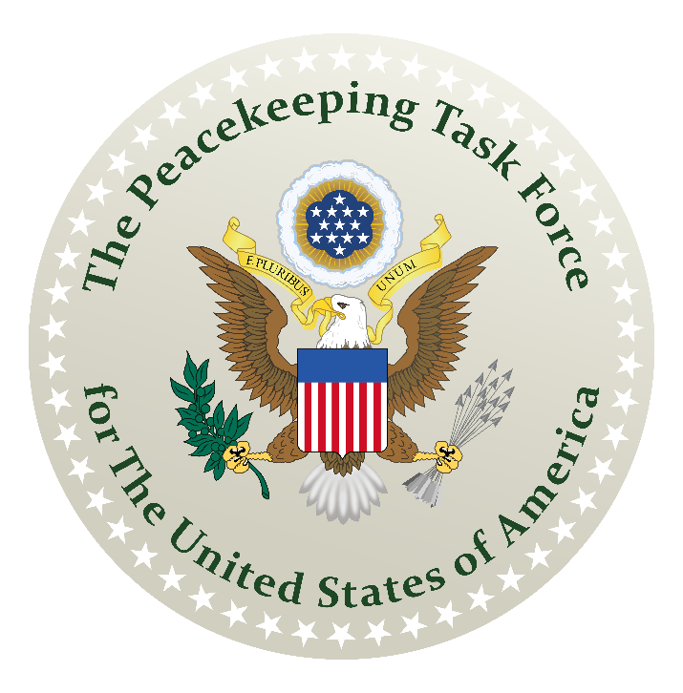
Our Republican Form of Government
How to Assemble the De Jure Government of America
A Guidebook for Reconstructing a Republican Form of Government
An Initiative of The American Government’s Resurgence Project
Prepared by: The Union State Assembling Guidebook Committee

How to Assemble the De Jure Government of America
A Guidebook for Reconstructing a Republican Form of Government
An Initiative of The American Government’s Resurgence Project

Acknowledgements

Thanks to graphic artists Tim

Contents
How to Assemble the De Jure Government of America 1
Acknowledgements 1
Key Points 3
Section 2: Our Republican Form of Government 4
A. Our Government Supposed To Be 4
B. American Government Structures 5
1. Guaranteed by Unanimous Declaration of Independence 5
2. Guaranteed by Northwest Ordinance 6
C. Counties Form a Union State 7
Take Away…? 9

Key Points

In Section 2 – Our Republican Form of Government

Section 2: Our Republican Form of Government

The American Government started out in 1776 as a “republican form of government” – this is an important distinction. “Republic” is a male gender form in Latin and “republican” is a female gender form in Latin. They are not the same and imply substantially different forms of government.
With a "republican form of government" everyone in this country has both rights and responsibilities. Everyone has the right to own land and other property interests. Everyone has a duty to uphold the public law. Everyone has a duty to defend our country. Our nation extends down to the poorest and up to the richest among us. We are all equal in our political status, all enabled to elect fiduciary deputies to conduct our public business, all equally protected under the Public Law.
Bottom Line: educate everyone as to the current effort to confuse our "republican states" with their State Republics doing business as STATES OF STATES ----incorporated "STATES", and to confuse our civilian government with their own Civil Government, which is a foreign subcontractor on our shores.
The republican form of government provided by the county/town level local government
occupying the soil jurisdiction and is created when (and only when) people claim their birthright political status and the people join together to create a General Assembly and build their County Jural Assembly. Please note that our right to peaceably “assemble” is one of the guarantees of all three Constitutions.
- Our Government Supposed To Be

As you can now see, Nevada Republican Government (or any one of the 50 states) derives from the statewide assembly of counties, Nevada derives from a State Assembly of county people delegates, and The State of Nevada results from the Nevada State Assembly doing business as The State of Nevada.

Our government as It Is Supposed to Be:
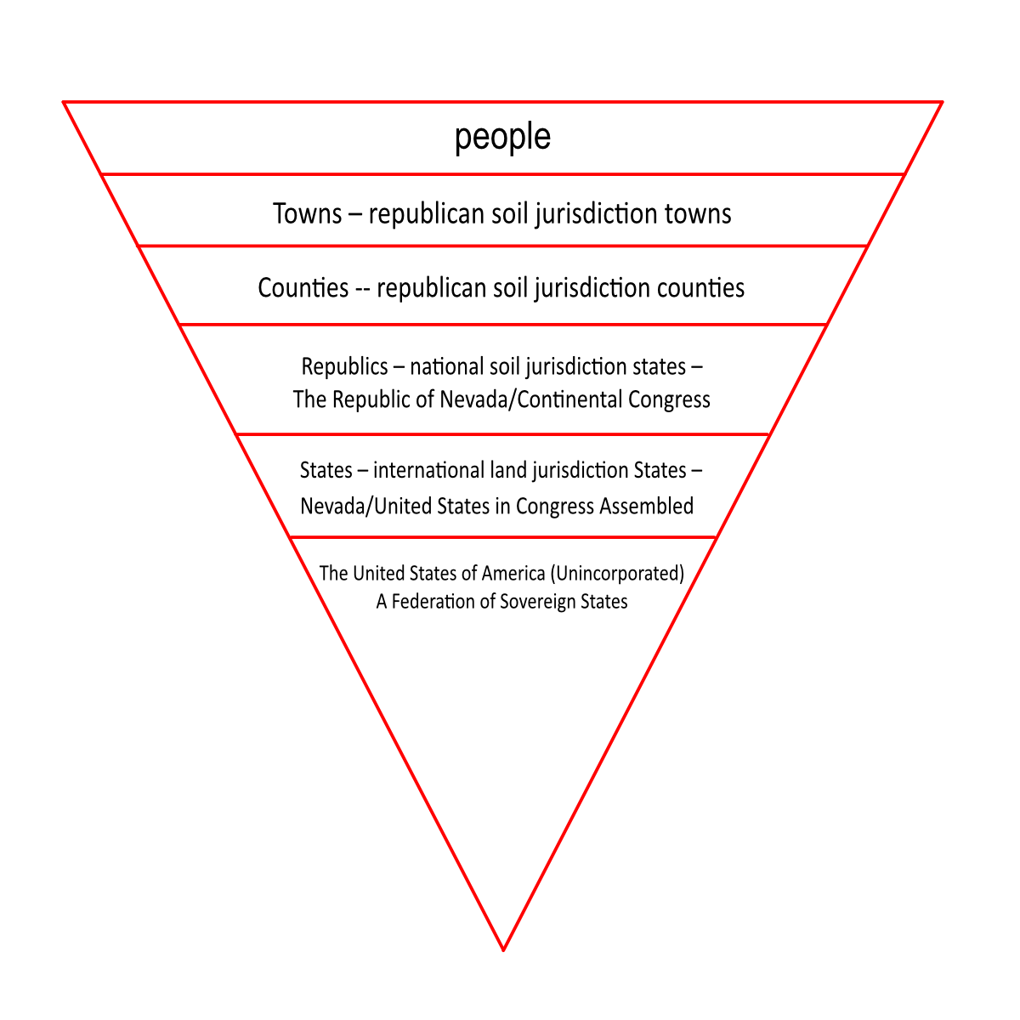

You are in the same boat as many Americans -- confused, angry, wanting to do something, but not knowing what to do or how to do it. This is primarily because you were never taught anything valuable about how your republican form of government is supposed to be organized and operated or why.

The short answer is to organize towns (or parish), county, and state unincorporated General Assemblies and jural assemblies. The people will delegate powers to these deferent structures to do the jobs that is required to build the government they are wanting to protect the people and their assets. That is Job One, and the good folk of Nevada and the good folk of North Caralina and Florida and Texas have already done the trail blazing for everyone else. As a result, you can use this guidebook published by the Union State-County Guidebook Assembly as a template to organize your own local jural assemblies for your towns, counties, and Union State.

- American Government Structures

The basic building block of our government is each individual living men and women, then, the family unit, then the community in which the family or individual lives, then the county which serves them as a local government, then the Union State that serves them at the national level as their nation-state, then the State of the Union that serves them at the international level, then the State of State that serves them in matters of commerce.

Thus: individual > family > community > county > nation-state > international State > State of State.
The Union State formed of all the Counties within the geographical boundaries of each State holds the national soil jurisdiction and is the instrumentality of each nation-state formed before, during, and after what is called the American Civil War. Each such nation-state is recognized as “free, sovereign, and independent” in the Treaty of Paris (1783) and other treaties generated by the peace process ending The War of Independence.
When all the Union States act together for their mutual benefit, they are recognizable by their instrumentality known as The United States.

- Guaranteed by Unanimous Declaration of Independence

This entire country takes its genesis from The Unanimous Declaration of Independence -- often simply called and titled "The Declaration of Independence" -- a moniker which includes all jurisdictional versions.

This unanimously approved Declaration was established on the land and the soil jurisdictions and was quickly followed by declarations of the same on the sea jurisdiction and the air jurisdiction, too. We see these additional declarations today and recognize them by the change in the form of the date of publication: 4th of July, July 4, 1776, and 4 July 1776.
This is actually and factually how our country came into existence as a separate and unified entity: (1) unanimous declaration, (2) battle, (3) victory by force of arms, (4) peace process to establish treaties.

Federal service contracts – What are these contracts and what does it mean to all the people that wants their independence. The contracts we are talking about are the 3 Constitution from 1776, 1789, and 1790. They were formed to delegate power to the subcontractors to give us services we needed at the time of building the government. As we all know at that time, we did not have the resources and knowledge. At those times the founding fathers set out to make sure the people in the colonies (now known as counties) and their Union State were protected from outside forces.

So, what are these Constitutions? They are service contracts, laying out duties and delegated powers to perform these duties. Like all Constitutions, they establish a relationship between the Parties entering the service contract, in this case, the States of the Union, and a Federal Service Provider--- or, as
in this case, three different service providers.

The first such Constitution is The Constitution for the United States of America (1787). The Service Provider was "States of America" which is the doing-business-as-name of the original Confederation of States-of-States formed in 1781. Land jurisdiction powers were delegated.

The Constitution of the United States of America (1789) -- the Service Provider was "the United States of America" -- the doing business as name of the British Territorial Government, a name that directly mirrors the name of our Federation of States: The United States of America. Water jurisdiction
powers were delegated.

The Constitution of the United States (1790) -- the Service Provider was "the United States" one of the doing business as names of the Holy Roman Empire. Air jurisdiction powers were delegated.

These British Territorial service vendors were never meant to provide any delegated services related to our land jurisdiction and have never been authorized to represent our States of the Union in this capacity. They secretly usurped against the designated and intended American federal services provider, claimed unauthorized “emergency powers” and made sure not to tell the American People to whom they owed “good faith service”.

We, the American Government, hired these other Principals to provide specific enumerated services, and we empowered them to provide those services as stipulated by their constitutional service contracts.

All three Federal Constitutions include good faith service provisions.

We believe that it should be clear now who we are and why the American Government is the actual government of this country, and why the “United States” Government, also known as the Federal Government, operating out of Washington, DC, is a nest of “government services providers” – mere vendors that have usurped against their employers.

- Guaranteed by Northwest Ordinance

From the beginning, our efforts have been fraught with misunderstandings, conjectures that are plausible, but ultimately incorrect, and outright lies spun to create confusion and division.

One such obfuscation is the idea that "the original thirteen" colonies and later the Estates/States derived from them, had some special standing or material or ownership interest in the States that were formed later in our country's history.

Any such ownership interest was short-lived, and pertained only to that period of time when, under the rules of the Northwest Ordinance, the incipient States were defined as territories and were temporarily under the control of the British Territorial Federal Subcontractor.

Once sufficiently populated and defined, these "territorial states" were enrolled as full-fledged Union States under the Equal Footing Doctrine which allowed that all States enjoyed the same status and authority and benefit as all the other States in the Union.

- Counties Form a Union State

Remember now that when we say "Union" in this context, we are not talking about the Northern Confederacy that was involved in the so-called Civil War. We are talking about the Union States formed from the patchwork of Counties which together control the soil jurisdiction of each State.

In the world of wo/men, we established our sovereign nation-states, known as the Union States, as a consequence of our own natural sovereignty. Then we delegated powers to the Union State to conduct the business of the people in those towns and counties.

When you stand up and build your towns and then the counties you are building towards building the Union State of your State and then forming your State of the Union.

So, the original plan was that the sovereign Union States created the States of America as a business partner to represent their interests and powers in global commercial affairs, and the States of America got the service contract known as The Constitution for the United States of America and delegated some of those powers to the Federal Republic. We have to remember that the “States of America” is not the government of the people but a service contract to do business for the people.

Please note that all sovereign power remained vested in the Union States. Delegated by the people.

Both the States of the Union and the “States of America” merely "represented" the Union States ---- with the States of the Union operating in international jurisdictions, the States of America operating in global (commercial) jurisdiction.

Their Sovereignty is represented in international realms by their unincorporated Federation of States known as States of the Union (This Federation is viewed as a Confederation from the standpoint of the Union States, but as a Federation by the rest of the world).

The States of the Union belong to the Union States.

The State of the Union is the international State instrumentality belonging to the people living in the Union State. This is the more familiar State entity by which the Union States typically conduct international business on the land and at sea. When we combine these international States of the Union and they conduct business in their mutual self-interest, they do so as the unincorporated Federation of States known as The United States of America.

The realms of land and soil exist in perpetual union as a fact of nature, so that the sovereign Union States abide in eternal joinder with their States of the Union, with the Union States directly presenting the government of the nation-states – our national jurisdiction, and the States of the Union representing the Union States in international jurisdiction.

Only the people and their nation-states have sovereignty; all the rest of these instrumentalities only "represent" that sovereignty to different degrees and in different jurisdictions.

The Union States and the States of the Union still remain to this day.

As the Americans "returned" one by one to the land of this country, they repopulated the Towns, Counties, and Union States and they also, at the same time, repopulated the States of the Union.

The Union States still have the States of the Union operating in international jurisdiction and, if necessary, global jurisdictions, at the time these Pikers made their claims and began their rampage of racketeering and war-for-profit --- literally --- in our names.


Take Away…?

