Sources:
https://annavonreitz.com/fundamentalgovernmentstructure.pdf
https://annavonreitz.com/chartandupdate.pdf
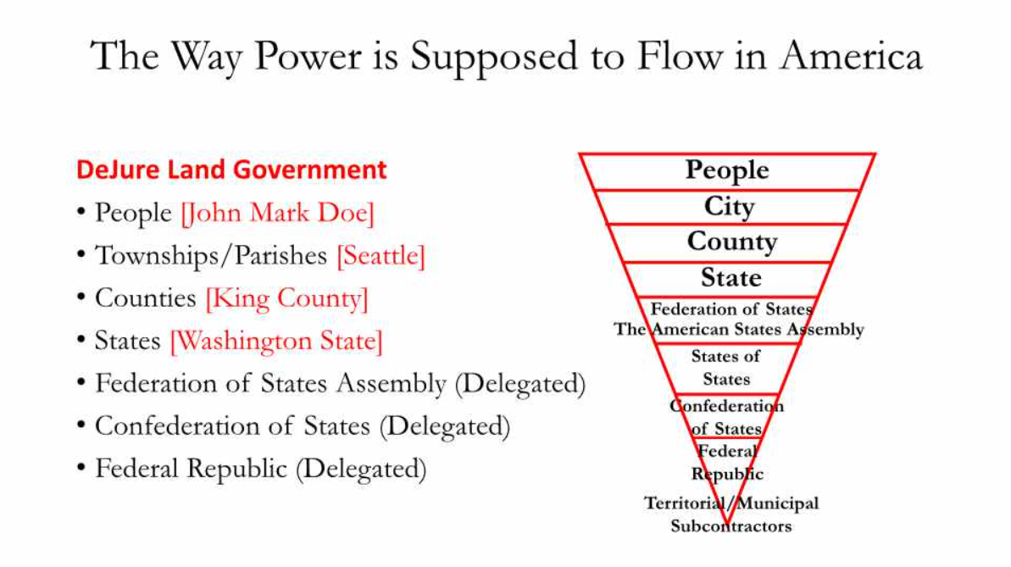

The Flow of Power Starts With the “people”
De Jure Government
people/person/national
Town
County
Federation of States
Confederation of States of States
Federal Republic
Territorial/ MUNICIPAL Subcontractors
State/People/Person/Citizen
- people [john quincy of the House Doe/John Quincy Doe]
- Towns (as in “township” or “city”) [Town of Pembroke]
- Counties [King County]
- States [Washington]
- Federation of States [Delegated]
- Confederation of States of States [Delegated]
- Federal Republic [Employees]
- Territorial and MUNICIPAL Subcontractors [Employees] (USA, Inc., US, INC.)

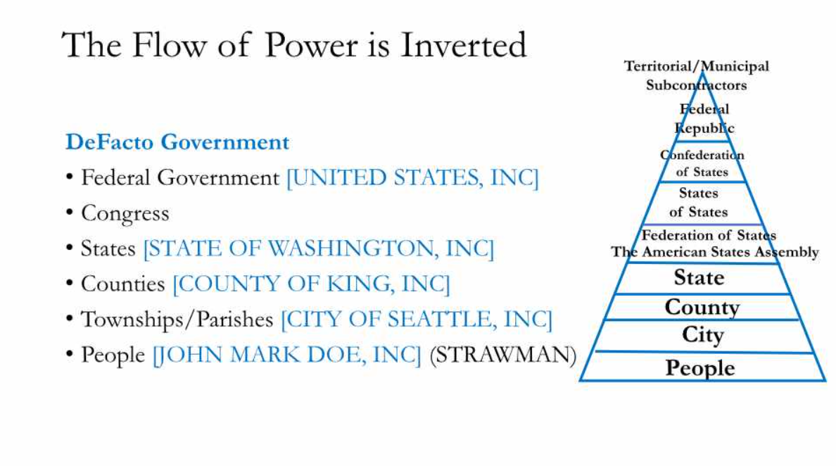
The Flow of Power Is Inverted to Top-Down
De Facto Government
USA, Inc./ US, INC.
Congress
President
Court
Department/ Agency
State
County/Township
Village/City
Citizen/Person
- Federal Government [Territorial USA, Inc./MUNICIPAL US, INC. Corporations]
- Congress [Territorial/MUNICIPAL Congresses]
- President [Territorial/MUNICIPAL Presidents]
- Courts [United States Supreme Court, Inc./US DISTRICT COURT, INC.]
- Departments and Agencies [Department of Defense, Inc./DOD, INC.]
- States [Washington State, Inc./STATE OF WASHINGTON, INC.]
- Counties/Townships [King County, Inc./Township of Pembroke/COUNTY OF KING, INC.]
- Villages/Cities [City of Seattle, Inc./CITY OF SEATTLE, INC.]
- Citizens/Persons [John Quincy Doe, Inc./JOHN QUINCY DOE, INC.]

The Way Power Is Supposed to Flow in America
Department/ Agency
State
Court
President
Congress
Territorial/MUNICIPAL
Subcontractors
Federation of States
State
Court
County
Town
people
County/Township
Village/City
Citizen/Person
people
Town
County
State
Federation of States
Confederation of States of States
Federal Republic
Territorial/ MUNICIPAL Subcontractors
USA, Inc./ US, INC.
Congress
President
Court
Department/ Agency
State
County/Township
Village/City
Citizen/Person

